Question 1
(Re)read Example 4.7 in Taylor. For me, the trickiest part was understanding the little step of geometry just before Eq 4.59, where Taylor says "the length BC... is r theta" Look at the picture, convince yourself you understand! If you don't, just say so in the space below. If you do - was it so obvious you didn't even have to think, or did it take a moment of head-scratching? (There's not much here you need to write, we just want you to think carefully about the geometry)

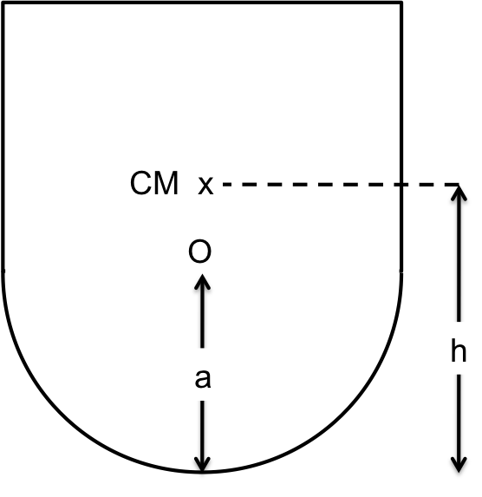
Question 2
Look at the figure below, which shows a possible design for a child's toy. You will be solving for the stability of this toy in an upcoming homework, no calculations are required for this preflight! The designer wants to build a "weeble" (which wobbles, but doesn't fall down :-) It is a single, solid object, the shape is a perfect hemisphere (radius a) on the bottom, glued to a solid cylinder on top. The CM is shown, it is "h" above the base.
For now - we just want you to look at the situation and visualize it. It sure looks like a 3-D object, yet we are in Taylor's chapter called "one-dimensional systems". Can we consider this situation to be a 1-D problem?
Yes, it’s 1-D.
No, it’s 2-D.
No it’s 3-D.
It’s ambiguous/other!

Question 3
Briefly, explain your reasoning to the previous question.

Question 4
A particle undergoes one-dimensional motion in a potential U(x), shown below. The horizontal line shows the total energy of the system. At what lettered point is its velocity the largest?
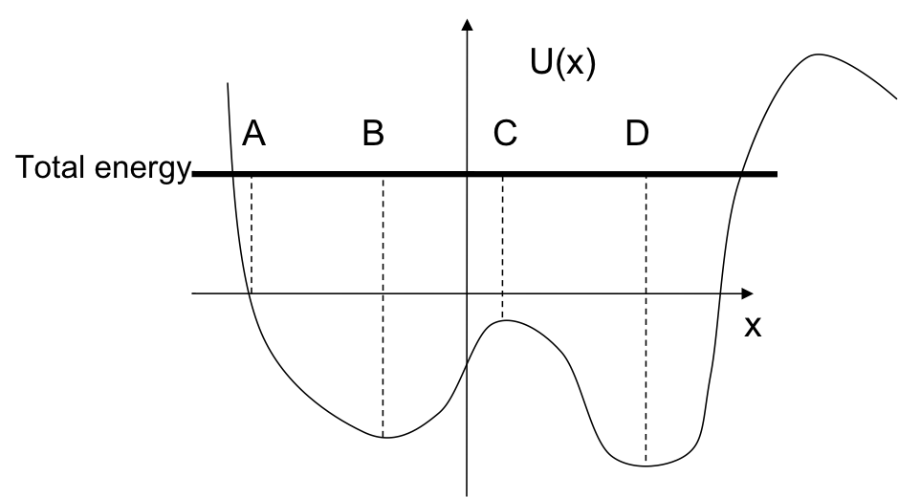
Question 4 options: A, B, C, D, or E) None of these, or MORE than 1!

Question 5
Briefly, explain your reasoning to the previous question.

Information
Every week, we will ask you to submit a question you have about the reading assigned for the upcoming class. What seemed hard, was something confusing, what would you like us to spend class time on? And/or, if you prefer, make a (constructive) comment on someone else's question!

