Question 1
How familiar/comfortable are you with working with complex numbers, and Euler's theorem (e^i theta = cos(theta) + i sin(theta)) (You can elaborate more in the next question)
Question 1 options: No problem
It’s ok, but I’m a little rusty/have a few weak spots
I’m not confident/I’m unfamiliar with this material

Question 2 (Feel free to elaborate on your previous response, if you want). But to get concrete:
In Phys 2170 (or earlier), when solving the ODE for a harmonic oscillator, you might have found a complex solution, Ae^(i omega t). That doesn't look real! Can you describe in words what the connection(s) was (were) between that very mathematically abstract result, and the old Phys 1110 "mass bobbing on a string" story?

Question 3
Look at Taylor's Fig. 5.4. In your own words, where did that come from? Why does THAT triangle (with those particular choices of sides) tell us about delta? (Could he have equally well drawn it with B1 and B2 flipped, for instance?)

Question 4
The figure below shows x(t) for two different oscillators. If we use the form x(t)=Acos(omega t + phi), which of the constants (A, omega, and/or phi) are DIFFERENT for the two oscillators, and how? (Select all that you agree with!)
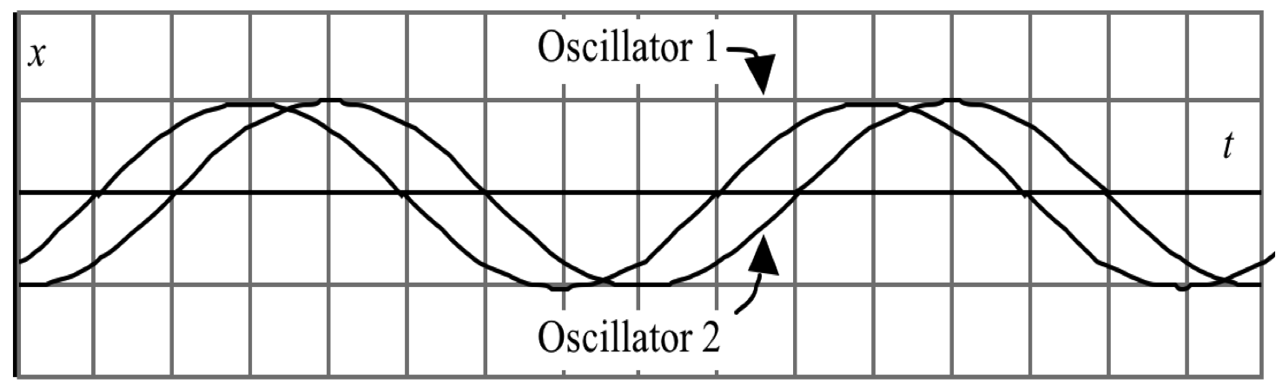
Question 4 options:
A is LARGER for Oscillator #1
A is SMALLER for Oscillator #1
A is the same for both oscillators
omega is LARGER for Oscillator #1
omega is SMALLER for Oscillator #1
omega is the same for both oscillators
phi is LARGER for Oscillator #1
phi is SMALLER for Oscillator #1
phi is the same for both oscillators

Question 5
Briefly, explain your reasoning to the previous question. What made you decide as you did? (Please comment on your reasoning about A, omega and phi!)
Information. Every week…

