Topographic maps and equipotential contours

conservative forces & equipotential diagrams
You and your best friend plan a hike along the Appalachian Trail in the White Mountains of New Hampshire. A topographic map of a portion of the trail is shown below. The smooth curves indicate locations of equal elevation, measured in feet above sea level. (Note: The darker lines mark elevation in 100-foot intervals, and the elevation lines for 2,300 feet and 2,700 feet are labeled.)
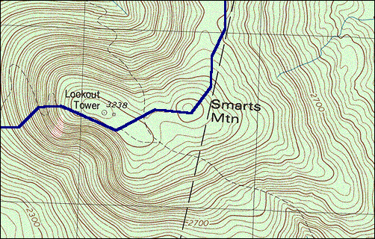
B
A
C

Three locations, A, B, and C, are marked at the same elevation of 3,000 feet above sea level.
Rank the three locations according to steepness of the slopes at those locations. Explain how you can use the elevation lines shown on the map to support your answer.
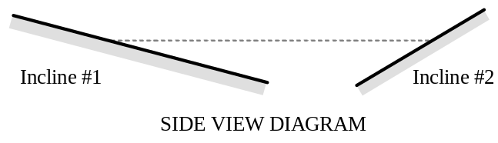(Hint: Consider the inclines shown in cross-sectional side view at right. On which incline would the elevation lines appear closer to one another?)

Suppose that at each of the labeled locations (A, B, and C) a large boulder became dislodged and started to move. (Assume that these are all “physics boulders,” all identical to one another.)
At each labeled location, draw a vector that represents the net force on the boulder after it has become dislodged. Explain how you can use the elevation lines to help you determine the correct directions and relative magnitudes of your vectors.

Consider the motion of each boulder from its starting point (from rest, at 3,000 feet elevation) to the moment it reaches 2,500 feet elevation.

Which boulder (A, B, or C) do you think will reach 2,500 feet elevation first? Explain.

Ignoring all frictional effects, how would you rank the boulders according to their final kinetic energy (i.e., upon reaching 2,500 feet elevation)? Explain your reasoning.

✓ STOP HERE and check your results with an instructor before proceeding to the next section.

Force and changes in potential energy
Suppose that we used x to represent spatial coordinates running west to east (with east being the +x direction) and y to represent coordinates running north to south (with north being the +y direction).

Explain how the lines of equal elevation on a topographic map could be used to indicate locations of equal gravitational potential energy.

If the function U(x, y) represents the gravitational potential energy at a location denoted by the coordinates (x, y), explain in words how you could use a topographic map to determine the value of:
• 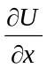 evaluated at a given location (x_{o}, y_{o})

• 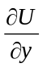 evaluated at a given location (x_{o}, y_{o})

The topographic map from section I has been reproduced below. (Note the x-y coordinate system superimposed on the map.)
B
A
C
+ y
+ x

For each labeled location, use the contour lines on the map to answer the following questions.
 | Location A | Location B | Location C
1. Is positive, negative, or zero?
2. Is 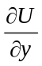 positive, negative, or zero?
3. Which is greater: 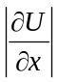 or 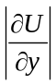?

The partial derivatives (∂U/∂x and ∂U/∂y) can be thought of as components of a vector called the gradient of the potential energy. For a situation in which the potential energy is a function U(x, y, z) of all three Cartesian coordinates, the gradient 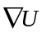of the potential energy can be written as follows:
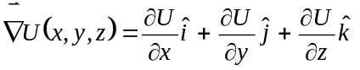

(When the potential energy is a function of only x and y, as has been the case on this worksheet, we ignore the (∂U/∂z) term in .)

On the basis of your results in step 1, carefully draw an arrow on the map at each of the labeled locations (A, B, and C) to indicate the direction of at that location.
Summarize your results for the vectors you have drawn:
• Does point in the direction of increasing or decreasing potential energy?

• Does point in a direction in which the potential energy changes the least or the most with respect to position?

• How does the direction of compare to the orientation of the equipotential contours near that location?

Compare your results from part II.C above to the net force vectors you drew in section I.

Your results should suggest a mathematical relationship between the net force 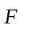and . What is that relationship? Explain.

Is the magnitude of a (conservative) force at a given location proportional to the potential energy at that location? If not, what can be said about the magnitude of the force? Explain.

Summarize your results: In order to determine the net force exerted on a particle at a particular location (x_{o}, y_{o}), what steps would you need to take:
• if you were given an equipotential contour map for the region that includes (x_{o}, y_{o})?

• if you were instead given the potential energy function U(x, y) for that same region?

