Assume the two differential equations 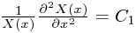and 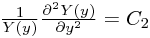
where C₁+C₂ = 0.
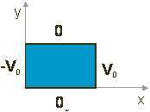
- Given the boundary conditions pictured to the right, which coordinate should be assigned to the negative constant? Please choose one.
a) x b) y c) Neither: C₁=C₂ = 0 d) It doesn’t matter e) It depends

Please explain your reasoning:

A student trying to solve Laplace's equation, 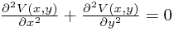, writes down a trial solution .

- For the trial solution that the student has chosen, would k and k' be related to each other, or would they be arbitrary constants? Please choose one.

a) Related to each other b) Arbitrary constants (not related) c) Not enough information

Please explain your answer to the previous question.
If you said k and k' where related, how are they related and how did you decide? If you said they are arbitrary, how did you decide?

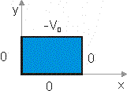
- The specific problem that the student is trying to solve has the boundary conditions shown to the right. Is the trial solution above a solution to this problem?

a) Yes b) No c) It depends

Please explain your answer to the previous question.
If you said yes, what can you say about the constants (A, B, C, D, k', k)? If you said no, why not? If you said it depends, what does it depend on?

- When trying to solve the differential equation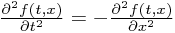 would the solution be OK?

a) Yes b) No c) It depends

Please explain your answer:

