You have a volume charge density given by $ρ\left(x,y,z\right)=aδ(y+2)$ (where is a constant, and refers to the usual Dirac-delta function).
What are the units of the constant ?
- Coulombs
- Coulombs per meter
- Coulombs per meter²
- Coulombs per meter³
- a is unitless
- Something else

What physical situation does this volume charge density represents?
- a point charge
- an infinite line of charge
- an infinite plane of charge
- a solid sphere of charge
- a spherical shell of charge
- something else

Please explain your answers to the previous two questions

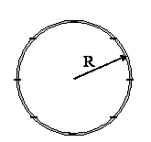

You have a thin spherical shell of uniform negative charge -Q centered at the origin with no other charge anywhere (i.e. all the charge is concentrated in a hollow shell at r=R).

If we set the zero point such that V(r=R)=0, what is the sign of the potential at infinity?
Please choose one:
- Positive
- Negative
- Zero
- It depends
- We do not have the freedom to set V(r=R) = 0 here!

Please explain your reasoning:

For the charged sphere in the previous question, where in space (if anywhere) does the divergence of E vanish? (Please select all that apply)
- At the origin
- Throughout the region r<R
- On the surface r=R
- Throughout the region r>R
- At infinity
- None of the above

Please explain your reasoning.

For the charged sphere in the previous question, where in space does the ∇xE vanish?
(Please check ALL that apply)
- At the origin
- Throughout the region r<R
- On the surface r=R
- Throughout the region r>R
- At infinity
- None of the above

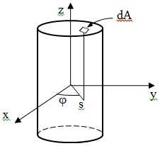
What is the infinitesimal area, dA, of a small patch on the cap of a finite shell centered on the z-axis? Please give your answer using cylindrical variables.

Which of the following could be a physically allowable static charge distribution (gray shading indicates a solid conductor, and “q” is some non-zero positive charge)? It is not necessary for the conductor to be neutrally charged but there are no additional charges outside the conductor.
Please circle ALL that apply.
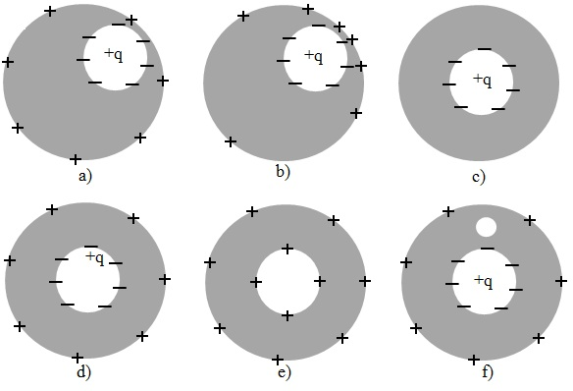
For any of the above which you think are unphysical, please explain why:

