In the following problems, vectors are written in boldface.

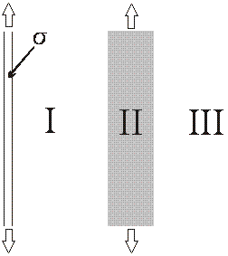
Consider the configuration to the right with an infinite plane with positive surface charge density and an infinite slab of dielectric (grey shading). In empty space, the charged wall by itself would create an E-field E₀.
Which way does the polarization P point in Region I (which is the region of space between the charged plane and the dielectric slab as in the figure)? Please choose one.
a) Left b) Right c) Neither (P is zero)
Please explain your answer to the previous question:

In region I the magnitude of the total E field is:
Please choose one.
a) Greater than |E₀| c) Equal to |E₀| e) It depends
b) Less than |E₀| but not zero d) Zero

In region II the magnitude of the total E field is:
Please choose one.
a) Greater than |E₀| c) Equal to |E₀| e) It depends
b) Less than |E₀|but not zero d) Zero

In region III the magnitude of the total E field is:
Please choose one.
a) Greater than |E₀| c) Equal to |E₀| e) It depends
b) Less than |E₀| but not zero d) Zero

Please explain your reasoning for the previous 3 questions:

