If the arrows represent the vector potential A, for which of the following are you CERTAIN there is there a nonzero B inside the dashed region? Please circle ALL that apply.
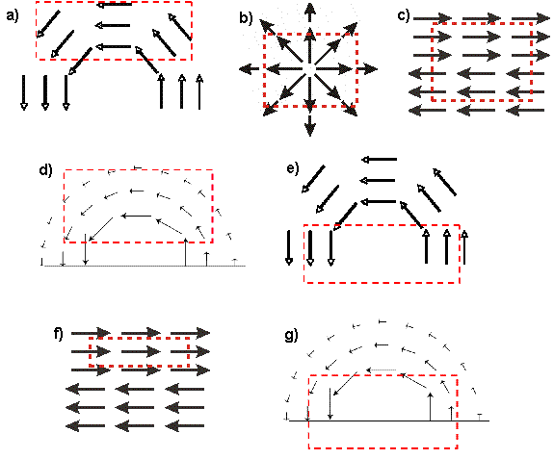
For each of the above pictures please explain briefly but clearly why you did or did not choose it:

The following statements about V, the electric potential, and A, the magnetic vector potential maybe be true or false. Please circleALL that are true.

a) V and A are physical quantities that can be directly and absolutely measured.
b) There can be a non-zero A-field throughout a region with zero B-field.
c) There can be a non-zero V-field throughout a region with zero E-field.
d) V and A are both related to potential energy.
Please explain your answer to the previous question. Choose two of the above statements and explain why you thought they were either true or false:

How are V and E related? Please select ALL that apply.
a) The divergence of V tells you E
b) The gradient of V tells you E
c) The curl of V tells you E
d) None of these

How are A and B related? Please select ALL that apply.
a) The divergence of A tells you B
b) The gradient of A tells you B
c) The curl of A tells you B
d) None of these

Please explain your answers to the previous two questions:

Suppose you had a long needle-like material with a strong B-field running up it, but B=0 outside the needle (i.e., where s is the usual cylindrical coordinate and C is a constant). What would, the vector potential look like outside the needle (and not near the ends of the needle)? Please choose one.

a) Pointing in z-hat and depends on s
b) Pointing in z-hat and doesn’t depend on s
c) Pointing in s-hat and depends on s
d) Pointing in s-hat and doesn’t depend on s
e) Pointing in phi-hat and depends on s
f) Pointing in phi-hat and doesn’t depend on s
g) A superposition of one or more than one of the above answers
h) Zero

Please explain your answer to the previous question briefly but clearly:

