What are the units of M?
- A
- A/m
- A/m²
- A/m³
- None of these
Please explain your answer to the previous question

Imagine two identical disk-shaped refrigerator magnets with uniform magnetization pointing upwards:
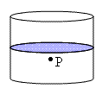
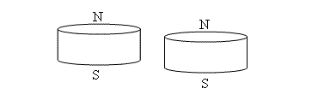
You stack them on top of each other so that they stick together.

At a point (P) just barely below the area where they are touching (shaded blue) which of the following changes substantially when the magnets are stacked compared to the same point when the magnets are separate: Please circle ALL that apply.
- B reverses direction
- M changes substantially
- Bound volume current changes substantially
- None of the above.
Please explain your answer briefly but clearly:

If each individual magnet has a magnetic dipole moment of magnitude m, what is the magnetic dipole moment of the two magnets stuck together? Please choose one.
a) Significantly less than m c) About the same as m
b) Significantly greater than m d) Can’t be determined

If each individual magnet has a magnetization of magnitude M, what is the magnetization of the two magnets stuck together? Please choose one.
a) Significantly less than M c) About the same as M
b) Significantly greater than M d) Can’t be determined
Pease explain your answers to the previous two questions briefly but clearly:

Where, if anywhere, are there bound currents on the two magnets stuck together? Please select ALL that apply.
a) Top surface c) Inside the magnets e) Outer cylindrical surface
b) Bottom surface d) There are no bound currents
Please explain your answer to the previous question:

