***👓 INSTRUCTORS MANUAL: TUTORIAL 1***

***The charged bike tire and Coulomb’s Law***

**Goals**:

1. Familiarize students with conventional notation in E&M: primed vs. unprimed coordinates, the three “r” vectors
2. Describe/interpret/represent a physical problem mathematically (learning goal 1)
3. Understand that 3310 is a much higher level than 1120, but also see the connection between the two courses (learning goal 10)
4. Check limiting cases to see if the answer makes sense (learning goals 5a & 7)
5. Practice with expansion (on challenge question) (learning goal 5a)
6. Communicate reasoning/thought process to group members, LA, and Instructor (learning goal 4)

**This tutorial is based on:**

* “E Field of a ring of charge” from Oregon State University “Paradigms”
* “Star Trek” activity from Oregon State University “Paradigms”
* Written by Darren Tarshis, Steven Pollock, and Stephanie Chasteen, with modifications by Ed Kinney, Michael Dubson, Bethany Wilcox and Markus Atkinson.

**Materials needed:**

Bike tire (or hula hoop), string, g.p.s. (or cell phone)

**Special Instructions:**

After students read the problem in part 2, groups are called individually. They were shown a physical model of the problem (see picture below) using a bicycle tire, strings, and cell phone. They were asked to identify which of the three strings was which “r” vector, and where the primed and unprimed coordinates are.

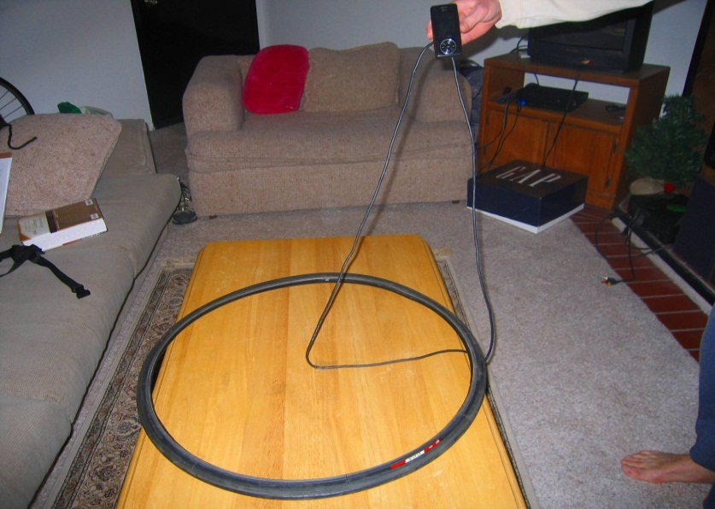

**Homework connections**:

* A note at the end of part 2iv includes the statement “A common HW and exam problem asks for the E-field caused by a charged **disc**. Hint: A disc is the sum of many rings. Did someone say “superposition”?” This could be modified to refer to a specific HW problem.

**Challenge Problem:**

Instead of a Tricorder, you now have a single electron. You release the electron on the z-axis, ever so slightly above (or below) the origin. It is free to respond to the Electric Field. What kind of motion will this electron experience? (What frequency of radiation would you expect to be emitted)?

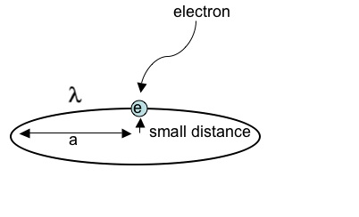

**Reflections on this tutorial:**

**Part 1.** In **question (i)** Although the three “r” vectors have been addressed repeatedly in class during the first week, several students were unclear on the direction of script-r, or not comfortable with the notation. This tutorial seemed valuable for getting them familiar with this notation, especially before using it on the first homework. One student made the comment, “I wasn’t sure if r-prime went to the charge, or the point, but since the charge was labeled with x′, y′, and z′, it seems pretty obvious it should point to the charge.” The wording of **question (iv)** causes some confusion to students that are not familiar with the vocabulary of Linear Algebra. A few students started to use cylindrical basis instead of the Cartesian basis. Some students don’t know how to change x and y to polar coordinates without looking it up. Going through the geometric diagram can be helpful. Even fewer students remember how to change to spherical coordinates. It seems to be most helpful to get them to come up with the transformation geometrically.

**Part 2.** The first two parts of this were fairly quick and students did not have significant difficulties. Some concern about simplifying there answers in **part (ii). Part (ii)** generated a lot of good discussion. Several groups spent a lot of time discussing what was being integrated over, y vs. y’. Identifying script-r in the next part was largely easy for most groups, though occasionally a group would try to express dy’ in terms of script-r. Surprisingly few students drew script-r or dq on the diagram.

**Part 3.** Students struggle with **question (i)**  Students were shown a physical model of the problem. They were asked to identify/point where the charge is located, where the points (x,y,z) and (x’,y’,z’) are, and which “r” vector each of the strings represents. They seemed to really enjoy the opportunity to visualize the problem in this way. One student even referred back to the model later in the hour when asking a question. I was, however, amazed that identifying the strings as three “r” vectors was not trivial for them. It took a moment for most of them to be confident in their answers (although one or two of them knew right away, and had no problem at all).

**In question (iii)** they know to make the substitution (where “R” denotes script-r). But they weren’t sure what script-r was in this situation, despite the fact they had just done this in part 1. Some students wanted to setup this integral as in introductory physics, and set the point on the z-axis, so that symmetry simplified it significantly. It was not easy for these students to accept that this problem was more complicated. Some groups attempted to use spherical coordinates, which makes the math harder and slows the group down significantly.

In **question (iv)** Most groups seemed to be able to build this expression without being given the integral form of Coulomb’s law. One group had to be reminded that electric field is a vector. There was discussion of whether integrating over a ring required one integral or three as well as whether the infinitesimal unit was dφ or adφ. There was also some uncertainty if you could mix cylindrical coordinates with Cartesian basis vectors.

In the **challenge question** multiple students expressed confusion concerning integrating a vector. They did not know if it required one integral, or three. Some students didn't know the z^ in the integral acts like a constant and can be pulled outside. Also, many students did not see that integrating sine or cosine over one period is zero. Therefore it was not obvious to them from the math that the x- and y-components of the integral went to zero. Graphing sine and cosine was a good way for them to see it mathematically, and thinking about the physical symmetry of the problem helped them realize this physically. Most groups were still struggling with this part or the previous part when the hour was done. One group of students really benefited from taking the large-z limit, and seeing that their answer had the right form for an electric field. It seemed like a clarifying moment. One group was surprised to find that the E-field vanished at the center, which led to some good discussion. Only a few of the groups made it to this point within the hour. No one attempted the challenge question.

**✯ Tutorial 1: Points, Lines and Rings, Oh My! ✯**

***Coulomb’s Law and “script r”***

**Part 1 – Script-r**

There is a charge +Q at point (,,).

We’re concerned with the field at point P = (x,y,z).

1. Draw on the graph: , , and (where is Griffiths’ “script r”).

P *= (x,y,z)*

*(x’,y’,z’)*

+Q

1. Express in terms of and .



1. Now express the Cartesian ( , , and ) components of in terms of the Cartesian components of  and .



iv. Express the Cartesian components of = [ , , ] from parts (i) – (iii) using cylindrical variables. (Don't try to write in a cylindrical coordinate basis. Write each of the *Cartesian* components of using appropriate cylindrical variables.)



P

+Q

*z’*

*s’*

’



=

=

=



v. Express the Cartesian components of from parts (i) – (iii) using spherical coordinates.

’

r’

’

P

+Q



=

=

=

.

**Part 2 – Constructing the Potential**

Recall from freshman physics that the potential at an arbitrary point P from a point charge, q, at the origin is given by

z

y

P



x

1. Using this, write an exact expression for the potential from two identical point charges located at (0,0,0) and (0,y2,0).

y1 y2

P

1. Now write an exact expression for the potential from a string of N identical point charges along the y-axis.

y1 y2 y3 y4 y5 y6

P

1. Write an expression for the potential at point P due to an infinite line of charge on the y-axis with uniform charge density λ.

λ

P

1. Re-write your expression in part iii using Griffith’s “script-r” notation. Which quantity in your equation does represent? Which quantity takes the place of the q from part i?

**Part 3 – Charged bike tires**

In the year 2240, a bicyclist, named Thomas, gets lost east of Boulder and gets a flat tire. Thomas pulls off the tire and then consults his Tricorder to find out what life forms are nearby. However, the flat tire has somehow been charged with uniform charge density . The Tricorder complains that the electric field from the tire is very annoying.

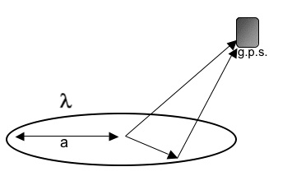

Tricorder

Your goal is to calculate the electric field produced by the electrically-charged tire (ring of line-charge density ).

1. The origin is at the center of the tire. Label the diagram with points (x,y,z) and (x’,y’,z’)
2. Now label the three vectors: , , and .
3. Write down a formal integral expression for the electric field. Be very explicit about *all* "short hand symbols" that appear in that integral (What does script-r-hat mean here, specifically?) Looking back at **Part 1**, which choice of coordinates would be most convenient?
4. Manipulate your integral into a form that could (at least in principle) be solved by a dumb computer or calculator. Then, simplify by putting the Tricorder on the z-axis, and evaluatethat integral!

(note: You have found the E-field caused by one **ring** of charge. A common HW and exam problem asks for the E-field caused by a charged **disc**. Hint: A disc is the sum of many rings. Did someone say “superposition”?)

**Challenge Question:**

Now place the Tricoder on the z-axis and evaluate the integral from part iv for the electric field. Check the limits for very large *z*, and *z* = 0. Do these answers make sense? Make a sketch of Ez as a function of *z*, including both positive and negative *z* axes. Are the units correct for an electric field? Where should the Tricorder be placed to avoid interference from the electric field?