***👓 INSTRUCTORS MANUAL: TUTORIAL 9***

***Ampere’s Law***

**Goals**:

1. Be able to make compelling symmetry arguments about the magnetic field (learning goal 5c).
2. Be able to choose appropriate Amperian loops such that the left hand side of Ampere’s Law, , is easy to calculate (Learning goals 5 and 6).
3. Be able to use Amperian loops to make arguments about the magnetic field in various areas of space.
4. Articulate expectations about the magnetic field (learning goal 7) and graph it (learning goal 2).
5. Communicate reasoning/thought process to group members, LA, and Instructor (learning goal 4).

**This tutorial is based on:**

* Written by Steven Pollock, Stephanie Chasteen, Darren Tarshis and Colin Wallace, with edits by Mike Dubson, Ed Kinney, Rachel Pepper and Markus Atkinson.

**Materials needed**:

Examples of coax cables (optional)

**Tutorial Summary**:

Students invoke symmetry and other arguments to make sense of the direction of the B-field. They calculate the integral for two loops oriented differently relative to a constant B field. They answer conceptual questions about Ampere’s Law. Next, they predict the B-field of a coax cable, and finally they calculate the B-field of the cable using Ampere’s Law. This tutorial may be used before students have been introduced to Ampere’s Law in class, and this approach may be preferable as it allows students to explore Ampere’s law before knowing the pattern for using it.

**Special instructions**:

When students started working on the coax section, I brought a very large coax cross section (used at a nuclear test site), so that they could see the inside in detail. This helped them visualize the problem. At the beginning of Part 2 there is a reference to a musical group (currently 3OH!3). The LA should update this group for currency each year. The following page can be printed and used as an in-class activity, perhaps in the last 15 minutes of the class period before the tutorial. It can be introduced as an activity that will be finished or followed up on in the tutorial.

A thin wire carries a uniform current I. This current produces a magnetic field, **B**. Up until now, you’ve always been told that magnetic fields loop around a current-carrying wire (Figure a. below), but how do you know that there are not other components to the magnetic field? Perhaps the magnetic field has a z-component (Figure b.) or a radial component (Figure c.).



i. Can you think of any convincing arguments for why there shouldn’t be a z- or s- component? It might be useful to consider symmetry, Maxwell’s equations, and any laws that have recently been covered in class.

**Reflections on this tutorial:**

**Part 1**

This section is designed to assist students in “unpacking” the left-hand side of Ampere’s Law. This part of the tutorial changes the orientation of an Amperian loop from the standard alignment with the field to a non-standard alignment, so that students must recognize that the dot product picks out the component of the magnetic field parallel to *dl* for each side, and decide which direction to integrate around the Amperian loop. Students should realize that both Amperian loops yield the same results, and recognize the importance of aligning a loop to take advantage of the symmetry.

This tutorial uses the technique of “bridging” to help students move from simple to more complicated scenarios. Students quickly realized that the closed loop integral should be thought of as a sum, and debated if  is the same on every point on a side of the rotated loop (**question iii**). Some students struggled to calculate the angle between *B* and *dl*. I was helpful for students to drqw *dl* on each side of the loop; it is important that students are explicit about where *dl* is and its direction in order to evaluate this integral and the sign of each component of the integral. The debates generated in this section may force students to confront previously hidden difficulties regarding line integrals. **Question(v)** was easy for most students, but a few did not realize that if symmetry exists then can give information about B. This is key as this is the reason that Ampere's Law is of any use. Most students recognized which loops provide information about the magnetic field (**question vii**), though this part takes them some time.

**Part 2**

One student remarked that, without an instructor’s guidance, they went through Part 2 without much in-depth thinking. **Question(i)** can lead to some good discussion. The students were quick to realize that the charge doesn't just flow down the surface of the metal because the resistivity would depend on R instead of A and that the charge couldn't just flow down the center because it does depend on A. The students had trouble with reasoning why it would flow uniformly throughout the wire, and may need instructor guidance at this point. In **question(iic)** it was beneficial for students to predict the answer they expected through a graph – this activity prompted much good discussion. **Question(iiic)** is a longer calculation than the rest and slowed the students significantly. Many students were expecting a linear decay in this section, but the actual field is more complicated being a superposition of the decaying field from the inner cylinder and the enclosed section in the outer cylinder. For the students that made it to **question iv** they seemed a little surprised to learn that the B-field in a coax cable is on the same order of magnitude as the Earth's field.

**Relevant Homework Problems**

**Ampere’s law- themes and variations**



Consider a thin infinite sheet with uniform surface current density  in the xy plane at z = 0.

**A)** Use the Biot-Savart law to find **B**(x,y,z) both above and below the sheet, by integration.

**Note:** The integral is slightly nasty. Before you start asking Mathematica for help - simplify as much as possible. Set up the integral, be explicit about what curly R is, what da' is, etc, what your integration limits are, etc. Then, make clear mathematical and/or physical arguments based on symmetry to convince yourself of the *direction* of the **B** field (both above and below the sheet), and to argue how **B**(x,y,z) depends (or doesn't) on x and y. (If you know it doesn't depend on x or y, you could e.g. set them to 0... But first you must convince us that's legit!)

**B)** Now solve the above problem using Ampere's law. (Much easier than part a, isn't it?)   
Please be explicit about what Amperian loop(s) you are drawing and why. What assumptions (or results from part a) are you making/using?

*(Griffiths solves this problem, so don't just copy him, work it out for yourself!)*

**C**) Now let's add a second parallel sheet at z = +a with a current running the other way.

. Use the superposition principle (do NOT start from scratch or use Ampere's law again, this part should be relatively quick) to find **B** *between* the two sheets, and also *outside* (above or below) both sheets.

**D)** Griffiths derives a formula for the B field from a solenoid (pp. 227-228) If you view the previous part (with the two opposing sheets) from the +x direction, it looks vaguely solenoid-like (I'm picturing a solenoid running down the y-axis, can you see it?) At least when viewed in "cross-section": there would be current coming towards you at the bottom, and heading away from you at the top, a distance "a" higher. ) Use Griffiths' solenoid result to find the B field in the interior region (direction and magnitude), expressing your answer in terms of K (rather than how Griffiths writes it, which is in terms of I) and briefly compare with part C. Does it make some sense? *Why might physicists like to use solenoids in the lab?*

**Ampere’s law II**

Now the *sheet* of current has become a thick SLAB of current. So we must think about the volume current density **J**, rather than **K**.



The slab has thickness 2h (It runs from z=-h to z=+h)

Let's assume that the current is still flowing in the +x direction, and is uniform in the x and y dimensions, but now **J** depends on height linearly,  inside the slab (but is 0 above or below the slab). Find the **B** field (magnitude and direction) everywhere in space (above, below, and also, most interesting, *inside* the slab!)

**✯ TUTORIAL 9: UNPACKING AMPERE’S LAW ✯**

Part 1 – Ampere’s Law

(i). Write down Ampere’s Law in integral form:

(ii). Imagine there is a constant magnetic field whose direction is given by the field lines shown below. An Amperian loop is also shown below (dashed lines).

a) What is for each side of the loop?

Side I:

Side II:

Side III:

Side IV:

b) What is?

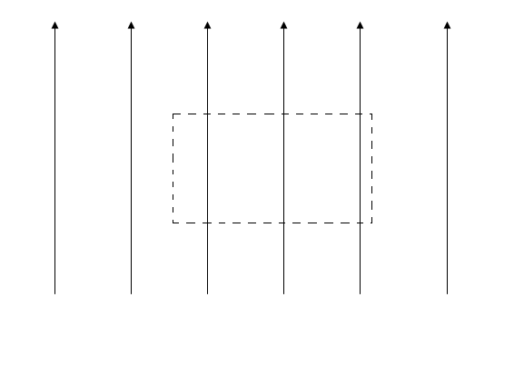

I

II

III

IV

(iii). Now imagine rotating the Amperian loop such that it makes an angle θ with respect to the magnetic field (shown below). Calculate for each side of the loop. What is?

Side I:

Side II:

Side III:

Side IV:

:

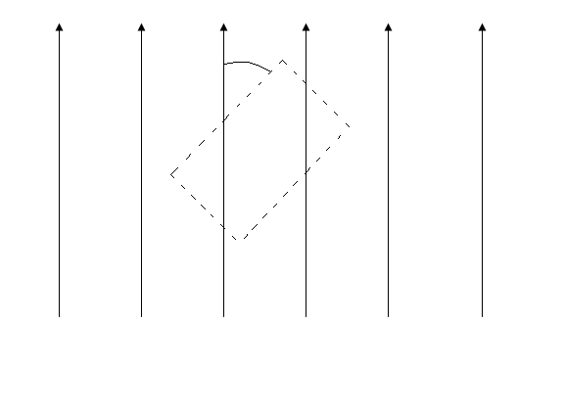

IV

III

II

I

θ

Compare  in question (ii) and (iii). Do they make sense? Explain.

(iv). Qualitatively explain how your results for questions 2 and 3 would change if your Amperian loop was a circle instead of a rectangle. Why is a rectangular Amperian loop better for this problem than a circular Amperian loop? Explain. What sort of situation might you want a circular Amperian loop for and why? Be explicit.

(v). If  for an Amperian loop (not necessarily the one in questions 2 and 3), can you conclude anything about the magnetic field **B**? Explain.

(vi). What does it mean if is not zero?

(vii). Consider the long fat cylindrical wire with a known, azimuthally symmetric current density **J** shown below.

Look at the various loops shown in the figure, and decide what information, if any, Ampere's law applied to each loop might provide about **B.**

Loop a: (it’s centered on wire):



Loop b:

Loop c:

Loop d (also centered):

Loop e (also centered):

Loop f:

Part 2 – Applications of Ampere’s Law

While studying intensely for your physics final, you decide to take a break and listen to your stereo. As you unwind to a little 3OH!3, your thoughts drift to newspaper stories about the dangers of household magnetic fields on the body. You examine your stereo wires and find that most of them are coaxial cable: essentially one conducting cylinder surrounded by a thin conducting cylindrical shell (the shell has some thickness). At some moment in time current is traveling up the inside conductor, and back down the conducting shell. As a way to practice for your physics final you decide to calculate the magnetic field at different radii.



(i). Ohm's law for a wire says: Resistance ∝ Length/(Cross-Sectional Area). What does this dependence imply about the current density **J** throughout the body of a conducting wire? Is all the current concentrated right at the center of the wire, or does it only flow on the outer edges? Or, does it spread out uniformly across the cross-sectional area? How would you expect the resistance to depend on the dimensions of the wire (e.g., radius or area) for these different cases? What do you conclude about the current density **J**?

(ii). Before you do any calculations, think about what answers you expect in the following questions a, b, and c.

a) Is there a magnetic field inside either of the two conductors?

b) How should I1 and I2 compare in order to produce no magnetic field

outside of the coax?

c) For the case of |I1|= |I2|, sketch a *qualitative* graph of **B** in the four regions: s < a, a < s < b, b < s < c, and s > c. Try to do this *without* solving the problem first! (e.g., is B zero, growing, falling?)

**B**

s

a b c

(iii). Now, using your model for **J** from question 1 in this section, calculate **B** in the four regions (you may assume I1 and I2 have the same magnitude *I*):

a) s < a

b) a < s < b

c) b < s < c

d) s > c

Based on your calculations, sketch a *qualitative* graph of **B.**

**B**

s

a b c

How does this graph compare with you prediction in part ii?

(iv). If *I* is 1 Amp (not an unreasonable size), what is the maximum value of B produced? Where is that maximum B produced? What is B at your location in the room? At either of these places, how does it compare with the earth's magnetic field (about 5 x 10-5 T)? What do you think about the newspaper's concerns? You may find the following number useful: μ0 = 4π x 10-7 N/A2.