Question 1 Exams don't stop the class! We're in section 5.4 and 5.5 of Taylor for this preflight... Look at the figure and select whether you think this represents un-damped, under-damped, critically-damped, over-damped, or "ambiguous/can't tell" motion. (You will have the chance to explain your reasoning after the last figure)
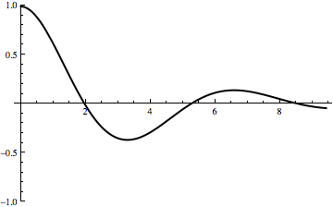
Question 1 options: No damping, under-damped, critical-damping, over-damped, ambiguous/can’t tell

Question 2 Look at the figure and select whether you think this represents un-damped, under-damped, critically-damped, over-damped, or "ambiguous/can't tell" motion.
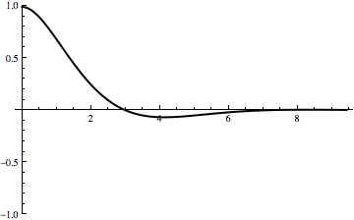
Question 2 options: No damping, under-damped, critical-damping, over-damped, ambiguous/can’t tell

Question 3 Look at the figure and select whether you think this represents un-damped, under-damped, critically-damped, over-damped, or "ambiguous/can't tell" motion.
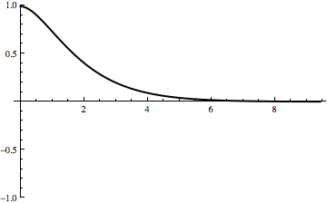
Question 3 options: No damping, under-damped, critical-damping, over-damped, ambiguous/can’t tell

Question 4
Look at the figure and select whether you think this represents un-damped, under-damped, critically-damped, over-damped, or "ambiguous/can't tell" motion.
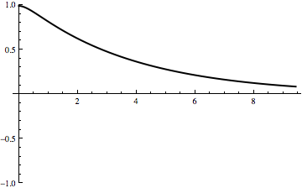
Question 4 options: No damping, under-damped, critical-damping, over-damped, ambiguous/can’t tell

Question 5
Here you can briefly explain your reasoning for any of the graphs above. (Please let us know which one you're referring to). I'm particularly interested in knowing how you decide, and if you think any are ambiguous, why?

Question 6
Taylor's Equation 5.68 is an essential one for what we're doing this week (and next). Under it he says, "You need to think very carefully about this potentially confusing formula". So... please think very carefully about this equation, and in your own words, try to explain it to us!

Information
This is exam week. Your homework assignment (for Thursday) will ask you to invent an exam problem, and also try someone else's from class. There is a discussion forum specifically designed for you to share those problems with each other.
For TUESDAY, you are not obligated to post a question or response as we normally ask - but if you want to, feel free, this week (and, from here on out) it's extra credit!

