Question 1
The diagram depicts a region of space. The dashed curves indicate positions of equal potential energy for a test charge +q that is placed at various locations within this region. (The potential energy difference between neighboring dashed lines is the same everywhere) Three such locations (A, B, and C) are labeled.
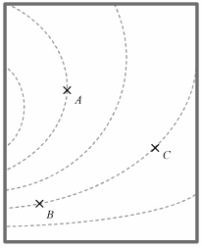
- Rank the locations A, B, and C according to the magnitude of the force that would be exerted on the test charge +q at those locations, from greatest to smallest. Explain your reasoning.
- Describe (as best you can in words) which direction the force on the test charge +q would be at point B?

Question 2
The three figures below represents vector fields F(x, y) mapped in the x-y plane. (They depict a vector quantity whose magnitude and direction varies only with x and y)

Fig 1: 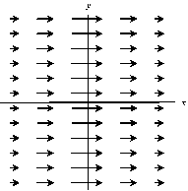

Fig 2: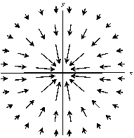

Fig 3: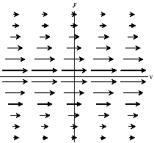
List which of the three vector fields shown above have a curl equal to zero everywhere in the x-y plane? Explain briefly how you decided. (It might be none, one, or more than one - just list them, or say "none".)

Question 3
If the fields in figures 1-3 above represent a force, which of them represents a conservative force? Explain your reasoning.

Information
Every week, we will ask you to submit a question you have about the reading assigned for the upcoming class. What seemed hard, was something confusing, what would you like us to spend class time on? And/or, if you prefer, make a (constructive) comment on someone else's question!
The place to do this is our "Discussion forum". Find the forum for this week, and post there!
(But, be sure to "submit" this survey at the bottom first, before going to that forum)
Note: this is an obligatory part of our weekly survey - I don't grade you on the content of what you post, but I DO need you to post something to get credit!

