In a bank heist gone awry, you and a friend are stuck inside a (conducting) metal bank vault.  Somewhere completely inside the otherwise very solid metal door is a lock-release mechanism that will trip if you drill through it.  This lock-release mechanism is a positively charged insulator.

Can you and your friend figure out the right place to drill by measuring the electric field inside the safe?

1. Yes (you could at least get close)
2. No, you cannot locate the charge no matter how sensitive your E-field detection capabilities are
3. Other/it depends

Please explain your reasoning.

Can your third accomplice, who is outside the safe, figure out where to drill by measuring the electric field outside the safe?

1. Yes (you could at least get close)
2. No, you cannot locate the charge no matter how sensitive your E-field detection capabilities are
3. Other/it depends

Please explain your reasoning.

Which of the following could be a physically allowable static charge distribution (gray shading indicates a solid conductor, and “q” is some non-zero charge which could be positive or negative)? Please circle ALL that apply. The conductor may have net charge (i.e., Q0.

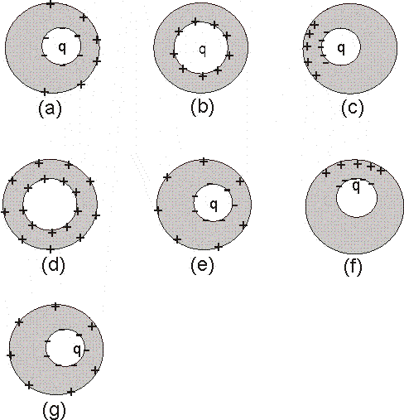

For each of the above explain how you decided it was (or was not) physically allowable.

Using our (standard) "curly R" notation of Griffiths (see his Fig 2.3 in section 2.1.3 if you've forgotten): On the diagram below, identify the labeled vectors (A, B, C, etc) with either r, r', "curly-r", or none of these.

NOTE that you may chose MORE THAN ONE for any given vector!

Flat disk with a uniform charge density.

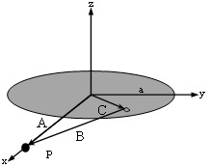

Which of the following represents the best formula for the magnitude of curly-r? By 'best' we mean the formula that would be most helpful for calculating E or V at point P. (As usual, φ is measured from the x axis)

1. Pretest01-Coulomb-Eqn1
2. Pretest04-Conductors-Curlyr-Eqn3
3. Pretest04-Conductors-Curlyr-Eqn1
4. Pretest04-Conductors-Curlyr-Eqn4
5. Pretest04-Conductors-Curlyr-Eqn2
6. Pretest01-Coulomb-Eqn6
7. Pretest01-Coulomb-Eqn5
8. None of these