In the following problems, vectors are written in boldface.

Consider a situation in which you have a linear dielectric (say plastic) which is placed into an external field E₀.
Griffiths says that in a linear dielectric D = ϵE. This is the main formula/result of Chapter 4.4.1. But it’s a little confusing - there are now several possible E-fields inside the dielectric, among them for example, E₀, E_{induced}, E_{induced} + E₀, E₀ - E_{induced}, and E_{induced} - E₀. Which of these, if any, is the E in the above equation? Please choose one.
a) E₀ b) E_{induced} e) E_{induced} + E₀
d) E₀ - E_{induced} e) E_{induced} - E₀ f) None of these g) It depends

Please explain your answer briefly but clearly:

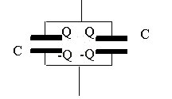
Consider two identical capacitors in parallel, as shown. Each one has charge Q.

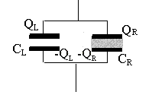
Now keep this system isolated (it is NOT connected to a battery), and insert a dielectric material into the RIGHT-hand capacitor. How do the free charges(left) and (right) compare? Please choose one:
a) > b) = c) < d) Not enough information

How does compare with Q (the original charge on the left capacitor)? Please choose one.

a) > Q b) = Q c) < Q d) Not enough information

Please explain your answers to the previous 2 questions briefly but clearly:

In the capacitor setup above, after the dielectric is inserted, how does the total E field in the region between the plates compare? Please choose one:

a) Greater on the left b) Greater on the right c) Equal in both capacitors d) Not enough information

Please explain your answer briefly but clearly:

