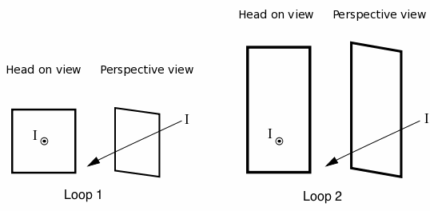Compare file_download for the two Amperian loops below. Which has a larger magnitude?

a) Loop 1 is greater

b) Loop 2 is greater

c) Both are the same and zero

e) Both are the same and nonzero

d) Not enough information

Please explain your answer briefly but clearly:

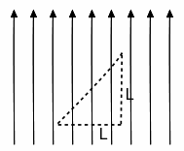

Imagine there is a constant magnetic field whose direction is given by the field lines shown.  Can you say anything about file_downloadaround the dashed triangular loop shown to the right? Please choose one.

a) Yes, the integral is nonzero b) Yes, the integral is zero c) No, more information is needed

Please explain your answer briefly but clearly:

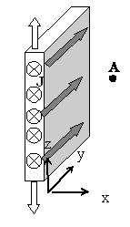

We have a large (infinite) *sheet* with a uniform current density J flowing down it.   The current runs in the +y direction, as shown.  (The sheet is infinite in the y and z directions.)

Based on symmetry arguments, what variables (x, y, and/or z) is it **im**possible for **B**(x,y,z) to depend on at the point A shown (outside the slab, at some point with positive x, y, and z). Please circle ALL that apply.

a) x b) y c) z d) None of these

Briefly, why?

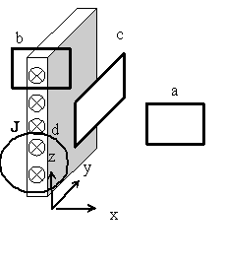Now, consider several small Amperian loop choices, labeled a-d.

(Note: Loops a, b, and d (the circle) are all in the plane of the page, i.e. parallel to the x-z plane.

Loop c is perpendicular to the plane of the page, i.e. it's parallel to the yz plane)

Circle ALL of these which might prove useful in learning something quantitative about **B**(x,y,z) *somewhere.*

a) b) c) d) e)None of these

For each loop, explain briefly why you did NOT choose it if you didn't, or what it's useful for if you did.