An airplane flies from Denver to Washington D.C. through the earth’s magnetic field. At a certain point on the journey the airplane is headed due east, and the magnetic field of the earth points north and down at about 40 degrees from horizontal.

Which wing of the airplane will accumulate positive charge? Please choose one.
a) Right b) Left c) Neither d) Not enough information

On which part of the wing will the positive charge accumulate? Please select ALL that apply.
a) Top b) Bottom c) Front d) Rear e) Other f) Not enough information

Please explain your answers to the previous 2 questions briefly but clearly:

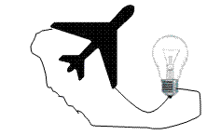

If a light bulb was connected in a circuit to the tips of the two wings, would the current run in the wire? Would the light bulb light? Why or why not?

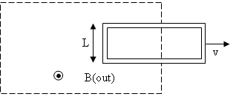
Consider a rectangular metal loop of height L, moving to the right with speed v, which is exiting a region with a magnetic field magnitude B. B is increasing linearly in time. Which direction is the induced current (if any) in the loop? Please choose one.
a) There is no induced current c) Counter-clockwise
b) Clockwise d) Not enough information
Please explain your answer briefly but clearly:
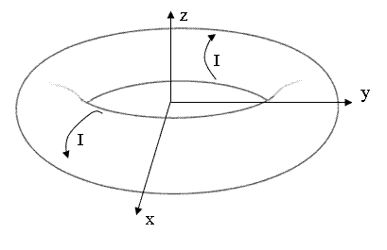

A toroidal coil is centered at the origin as picture with current wrapping around as pictured. There is no current running in the phi-hat direction. The current, I, is decreasing in time. Is there an electric field induced at the origin? Please choose one.
a) Yes b) No c) Not enough information

If so, what direction does this electric field point at the origin? Please select ALL that apply.
a) there is no E-field e) -y-hat
b) +x-hat f) +z-hat
c) -x-hat g) -z-hat
d) +y-hat h) Not enough information
Please explain your answers to the previous two questions briefly but clearly:

Now assume the current, I, is large but not changing. In this case, what direction does this electric field point at the origin?
a) there is no E-field b) +x-hat c) -x-hat d) +y-hat e) -y-hat
f) +z-hat g) -z-hat h) Not enough information
Please explain your answer to the previous question briefly but clearly:

