***👓 INSTRUCTORS MANUAL: TUTORIAL 11***

**Goals**:

1. Understand bound currents: the two types (surface and volume), what causes them, how they compare to real currents, how to calculate them
2. Estimate the bound current in a magnet (by experiment)
3. Gain familiarity with magnetic dipoles, and the field they produce
4. Understand the atomic effects that cause different types of magnetization (electron spin vs. electron orbit)
5. See that magnetization is in the world around us (i.e. grapes)

**This tutorial is based on:**

* Written by Steven Pollock, Stephanie Chasteen, Darren Tarshis and Colin Wallace, with edits by Mike Dubson, Ed Kinney and Markus Atkinson.
* “Push me a grape” is from Paul Doherty at the Exploratorium

**Materials needed**:

Compasses, toy magnets, meter sticks, grape demo (grapes, straw, string, stand, very strong magnet), superconductor levitation demo (liquid nitrogen, superconductor, small permanent magnet, plastic tweezers).

**Tutorial Summary**:

Students estimate the bound current of a toy magnet by comparing its field to the Earth’s. In the process, they confront magnetic dipoles and bound current. Then they apply their knowledge of magnetism to make sense of two demonstrations: repelling a grape with a magnet, and levitating a magnet over a superconductor.

**Special Instructions**:

Follow the instructions at the following links for the “Push me a Grape” activity:

<http://www.exploratorium.edu/snacks/diamagnetism_www/index.html> and <http://www.exo.net/~pauld/activities/magnetism/magnetrepelgrape.html>

**Reflections on this Tutorial**

This is a particularly strong tutorial. There was a constant hum of discussion, all the students seemed engaged and interested, and misconceptions were resolved. This tutorial had a point, an end goal (to estimate the bound current). In the process of achieving that goal, many relevant topics came up, like magnetic dipoles and bound current. The activity seemed to flow very well.

**Part 1**  This section took students about 40 minutes to complete. At this point in the semester, students should have developed some ability to question implicit assumptions. In **question (i)** two students asked how we know that the flat sides of the magnet are the poles (rather than the curved ends), and then checked it with a compass. **Questions (i)-(iv)** are a simple warmup, and makes the point that the geographic north pole is not the same as the magnetic north pole, which is clarifying for a few students.

In **question (v),** most students drew pictures of little currents canceling out inside the magnet. One group wondered why the field is uniform inside a magnet, and argued that the currents wouldn’t cancel inside the magnet if this were not the case. The instructor pointed out to students that these drawings of currents were of electrons orbiting the nuclei, but that the drawings could also represent electron “spin current” (which is actually the dominant effect). Some groups discussed the direction of the magnetic dipole orientation – the instructor noted that the small dipoles will orient in the same direction as the overall dipole field of the magnet.

Almost every student was confused by the definition of theta in the equation for B of a dipole in **question (vi).** Some thought this was the angle that the compass needle was deflected, and others thought it was the angle relative to magnetic north. The instructor helped them to resolve this by drawing a current loop (magnetic dipole), sketching its field (which students were familiar with) and identifying theta in order to make the equation match their sketch of the B field. Students had some troubles figuring out what to do with the ruler in order to estimate m (perpendicular to North gives the best estimate). The other difficulty was that students did not realize that the B-field from the magnet would equal the B-field of Earth when everything is aligned as in Figure 2.

Finding **K** in **question (viii)** also caused some difficulty, as most students realized (upon being prompted) that there were several different’s that could be used. Most realized that  for a particular surface informs us about the bound current on that surface (i.e.,  on the top surface is parallel to **M**, thus revealing that there is no bound surface current on the top of the magnet). One group noticed that the bound current on the outside of the doughnut-shaped magnet flows the opposite direction of the bound current inside the hole. The math of the cross-products for this question should agree with the model and sketch of atomic current in **question (iv),** and students can be encouraged to make this connection. We noticed several difficulties in translating from bound surface current **K** to bound current **I**: Some students attempted to multiply **K** by the surface area of the magnet (circumference * height), or by the volume of the magnet. In each group there was at least one student who knew that **K** should be multiplied by the perpendicular length (the height of the magnet). In the end, each group came to a similar estimate for **I** (which is similar to our estimate) of 1000-2000 A.

In **question (ix),** one student provided a nice analogy between bound current and a conveyer belt. The atoms are the rollers underneath the belt, and they stay in place. But the stationary rollers move the conveyer belt along the track, just as the stationary atoms move the bound current around the materials. Another student asked whether magnets are conductors due to this bound current? In **question (x)** we instructors agree that the magnetic effect is mostly caused by “spin current” rather than “orbital current.”

**Part 2.**  Students find the superconducting demo very engaging, and are surprised by the strong diamagnetism of the sugar water in the grapes. Instructors may facilitate a lively discussion based on student’s curiosity and skillful Socratic questioning. Because the demos are engaging, it is best to wait until most students have finished Part 1 to ensure that all students get a chance to work through the bulk of the tutorial. If you can get the magnet oscillating above the super conductor because of an accumulation of frost, this will lead to a lot of good discussion.

**Relevant Homework Problems**

**Bound currents I**

A) Consider a long magnetic rod (cylinder) of radius *a*. Imagine that we have set up a permanent magnetization inside, **M**(s,,z) = k , with k=constant.  *Neglect end effects.* Calculate the bound currents **😐**b and **J**b on the surface and interior of the rod. Use these bound currents to find the magnetic field **B** inside and outside the cylinder (direction and magnitude). Find the **H** field inside and outside the cylinder.

B) Now consider a cylinder of *finite* length. Sketch the magnetic field **B** and **H** (inside and out) for *two* cases: one for the case that the length *L* is a few times bigger than *a* and second for the case *L<<a* (which is more like a magnetic *disk* than a rod, really).

**Bound currents II**

Like the last question, consider a long magnetic rod, radius a. This time imagine that we can set up a permanent *azimuthal* magnetization **M**(s,z) = , with c=constant, and s is the usual cylindrical radial coordinate. *Assume the cylinder is infinitely long.*

Calculate the bound currents **😐**b and **J**b (on the surface, and interior of the rod respectively). What are the units of "c"? Use these bound currents to find the magnetic field **B**, and also the **H** field, inside and outside. (Direction and magnitude) Also, please verify that the *total bound* current flowing "up the cylinder" is still zero.

**Bound currents III**

Griffiths 6.12. (p. 272)



**Force between magnets**

A) Consider two small magnets with magnetic moments **m1** and **m2**. For the configuration shown ("opposite poles facing"), draw a diagram showing the relative orientation of the magnetic dipoles **m1** and **m2** of the two magnets. Then find the force between them as a function of distance *h*.

B) Now let's do a crude estimate of the strength of the magnetic moment of a simple cheap magnet. Assume the atomic magnetic dipole moment of each iron atom is due to a single (unpaired) electron spin. Find the magnetic dipole moment of an electron from an appropriate reference (and cite the reference). The mass density and atomic mass of iron are also easy to look up. Now consider a small, ordinary, kitchen fridge "button sized" magnet, and make a very rough estimate of its total magnetic moment **M**. Then use your formula from part A to estimate how high (shown as the distance *h*) one such magnet would "float" above another, if oriented as shown in the figure. Does your answer seem at all realistic, based on your experiences with small magnets?



**Paramagnetics and diamagnets**

Make two columns, "paramagnetic" and "diamagnetic", and put each of the materials in the following list into one of those columns. Explain briefly what your reasoning is.

Aluminum, Bismuth, Carbon, Air, a noble gas, an alkali metal, Salt, a superconductor, & water.

**✯ TUTORIAL 11: THE GENTLE ART OF ESTIMATION ✯**

***BOUND CURRENT IN A TOY MAGNET***

Part 1 – Estimating the bound current in a magnet

You know that currents create magnetic fields, but how *much* current does it take? You now have all the tools to estimate the bound current of an everyday toy magnet. The first part of this tutorial will guide you through an experiment to estimate the bound current within an ordinary toy magnet.

i. A compass needle is a magnet, and the arrow represents its north pole. If the compass needle (on a compass on the surface of the earth) is attracted towards the Earth as shown in Figure 1, label the magnetic poles of the Earth (“N” or “S”).

ii. Which direction is the current flowing inside the Earth? Label it with arrows. iii. If the compass needle deflects as shown in Figure 2, which pole of the toy magnet is closer to the compass? Label it (“N” or “S”).

iv. Which direction is current flowing on/in the toy magnet? Label it with arrows.

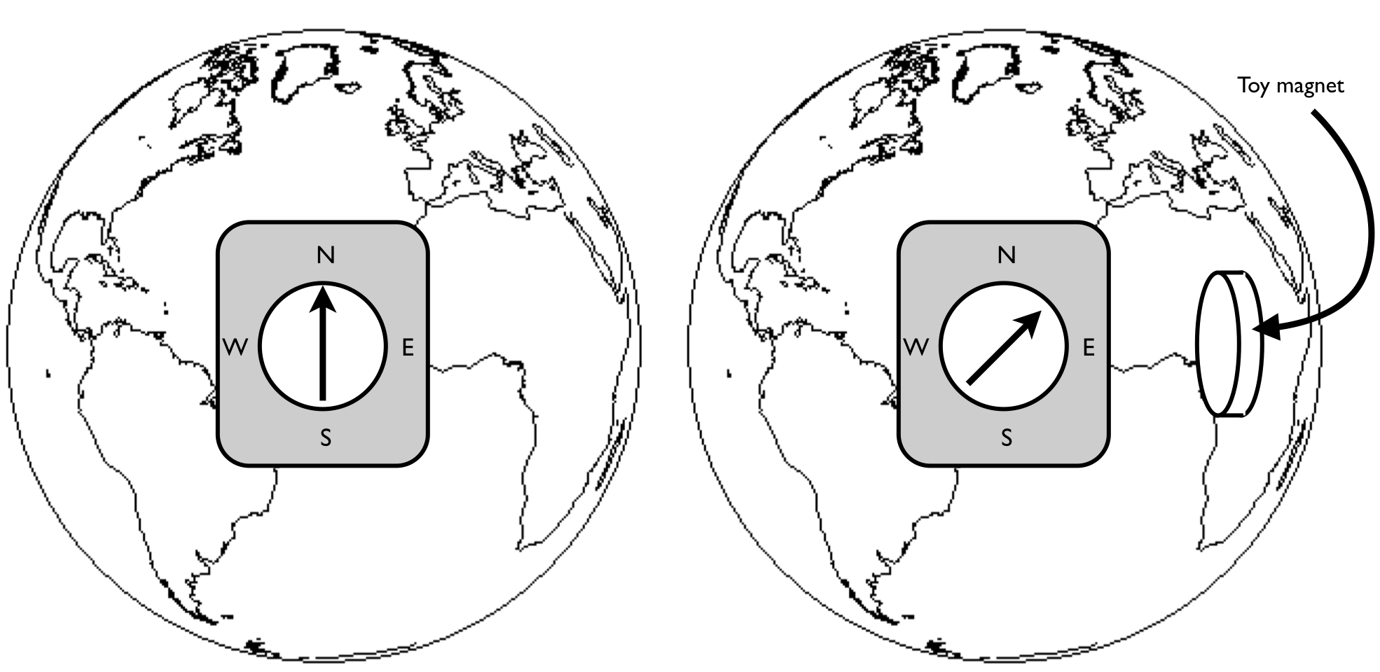

v.

Figure 1

Figure 2

v. Before you start estimating the bound currents of the toy magnet, do you expect there to be a bound surface current, bound volume current, or both? Sketch the atomic currents in the magnet to illustrate your claim.



vi. With your compass and toy magnet (and the earth) oriented as shown in Figure 2, estimate the magnetic dipole, **m**. You should use a meter stick. The following information may be useful:

 

Earth’s magnetic field is about 5E-5 T.

vii. Now you can find **M**, the magnetic dipole moment per unit volume.

viii. Estimate the bound current, **I**b. Potentially useful equations: ; 

ix. You have just estimated the bound current in/on a magnet, but is there *really* a current going around the magnet? Does an electron make a lap around the whole magnet?

x. Do you think that the bound current is an effect of electron “orbital current” or electron “spin current?”

Part 2 – Magnet Demos

Demo #1: Push me a grape

i. When we bring the magnet close to the grape, the magnetic flux in and around the grape is changing. Does magnetism, Lenz’s law, or a combination of both, cause the observed effect? (PHYS1120 refresher: Lenz’s law says that a current is induced that opposes changing magnetic flux.) How could you experimentally test your answer?

ii. What type of magnet is the grape?

iii. What is going on atomically inside the grape? (electron spin and orbit, bound currents, magnetic field lines, etc.)

Demo #2: Superconductor levitation

i. Why does the material only superconduct at very low temperature?

ii. If what’s levitated is a small permanent magnet, what type of magnet is the superconductor?

iii. If we turn the superconductor upside-down, will the permanent magnet “hover” underneath the superconductor?

iv. If we replaced the superconductor with a very powerful magnet (a HUGE solenoid), would the small permanent magnet still levitate?