Quantum Mechanics

Introductory Remarks: Q.M. is a new (and absolutely necessary) way of predicting the behavior of microscopic objects.
It is based on several radical, and generally also counter-intuitive, ideas:
1) Many aspects of the world are essentially probabilistic, not deterministic.
2) Some aspects of the world are essentially discontinuous

Bohr: "Those who are not shocked when they first come across quantum theory cannot possibly have understood it."

Humans have divided physics into a few artificial categories, called theories, such as
- classical mechanics (non-relativistic and relativistic)
- electricity & magnetism (classical version)
- quantum mechanics (non-relativistic)
- general relativity (theory of gravity)
- thermodynamics and statistical mechanics
- quantum electrodynamics and quantum chromodynamics (relativistic versions of quantum mechanics)

Each of these theories can be taught without much reference to the others. (Whether any theory can be learned that way is another question.) This is a bad way to teach and view physics, of course, since we live in a single universe that must obey one set of rules. Really smart students look for the connections between apparently different topics. We can only really learn a concept by seeing it in context, that is, by answering the question: how does this new concept fit in with other, previously learned, concepts?

Each of these theories, non-relativistic classical mechanics for instance, must rest on a set of statements called axioms or postulates or laws. Laws or Postulates are statements that are presented without proof; they cannot be proven; we believe them to be true because they have been experimentally verified. (E.g. Newton's 2nd Law, , is a postulate; it cannot be proven from more fundamental relations. We believe it is true because it has been abundantly verified by experiment. )

Actually, Newton's 2nd Law has a limited regime of validity. If you consider objects going very fast (approaching the speed of light) or very small (microscopic, atomic), then this "law" begins to make predictions that conflict with experiment. However, within its regime of validity, classical mechanics is quite correct; it works so well that we can use it to predict the time of a solar eclipse to the nearest second, hundreds of year in advance. It works so well, that we can send a probe to Pluto and have it arrive right on target, right on schedule, 8 years after launch. Classical mechanics is not wrong; it is just incomplete. If you stay within its well-prescribed limits, it is correct.

Each of our theories, except relativistic Quantum Mechanics, has a limited regime of validity. As far as we can tell (to date), QM (relativistic version) is perfectly correct. It works for all situations, no matter how small or how fast. Well... this is not quite true: no one knows how to properly describe gravity using QM, but everyone believes that the basic framework of QM is so robust and correct, that eventually gravity will be successfully folded into QM without requiring a fundamental overhaul of our present understanding of QM. String theory is our current best attempt to combine General Relativity and QM (some people argue "String Theory" is perhaps not yet really a theory, since it cannot yet make (many) predictions that can be checked experimentally, but we can debate this!)

Roughly speaking, our knowledge can be divided into regimes like so:

In this course, we will mainly be restricting ourselves to the upper left quadrant of this figure. However, we will show how non-relativistic QM is completely compatible with non-relativistic classical mechanics. (We will show how QM agrees with classical mechanics, in the limit of macroscopic objects.)

In order to get some perspective, let's step back, and ask
What is classical mechanics (C.M.)?
It is, most simply put, the study of how things move! Given a force, what is the motion?

So, C.M. studies ballistics, pendula, simple harmonic motion, macroscopic charged particles in E and B fields, etc. Then, one might use the concept of energy (and conservation laws) to make life easier. This leads to new tools beyond just Newton's laws: e.g. the Lagrangian, L, and the Hamiltonian,H, describe systems in terms of different (but still conventional) variables. With these, C.M. becomes more economical, and solving problems is often simpler.
(At the possible cost of being more formal)
Of course, what one is doing is fundamentally the same as Newton's F=ma!
The equations of motion are given in these various formalisms by equations like:
(If you've forgotten the Lagrangian or Hamiltonian approaches, it's ok for now…)
Just realize that
the general goal of C.M. is to find the equation of motion of objects:
Given initial conditions, find x(t) and p(t), position and momentum, as a function of time.

Then, you can add complications: E.g. allow for more complicated bodies which are not pointlike, ask questions about rotation (introduce the moment of inertia, and angular moment L=rxp), move to many-body systems (normal modes), etc…

Q.M. is about the same basic thing: Given a potential, what is the motion? It's just that Q.M. tends to focus on small systems. (Technically, systems with small action, ) And the idea of "motion" will have to be generalized a bit (as we shall see soon!)

Having just completed C.M., your initial reaction may be "but, size doesn't matter"! After all, neither L nor H cares about size, and C.M. often deals with so called "point objects". (Isn't a point plenty small?!) Unfortunately, it turns out that in a certain sense, everything you learned in 2210 and 3210 is WRONG! To be a little more fair, those techniques are fine, but only if applied to real-world sized objects. (As I said above, there's a regime of validity) Size doesn't matter up to a point, but ultimately, C.M. breaks down: if you try to apply the 3210 Lagrangian (or Hamiltonian) formalism to an electron in an atom, or an atom in a trap, or a quark in a proton, or a photon in a laser beam, or many other such problems, you will fail big time!

It's not just that the equations are wrong. You can't patch them up with some clever correction terms, or slight modifications of the equations, like relativity does at high speeds. The whole MIND SET is wrong! You cannot ask for x(t) and p(t). It's not well defined! Point particles do not exist. Particles have a wave nature, and waves have a particle nature. There is a duality in the physical world, which is simply not classical.

So, we must start from scratch, and develop a whole new framework to describe small systems. There are many new ideas involved. Some are formal and mathematical, some are rather unintuitive, at least at first. I will try to motivate as much as possible, and we'll study plenty of examples. Quantum mechanics comes from experiment! Feynman says that the one essential aspect to learn Q.M. is to learn to calculate, and we will basically follow this idea.

Q.M. is great fun: very weird, sometimes mysterious. Philosophers still argue about what it all means, but we will take a "physicist's view", mostly. Issues of interpretation can come later. As a colleague of mine once explained, it's kind of like trying to learn Swahili slang. First, you must learn a new language, and then you must learn a new culture, and only then can you finally begin to truly understand the slang...

The Postulates of Quantum Mechanics
The laws (axioms, postulates) of Classical Mechanics are short and sweet:
Newton's Three Laws. (You might add "conservation of energy" if you want to extend C.M. to include thermodynamics. You can add two more postulates (that the laws of physics are the same in all inertial frames, and the speed of light is constant) to extend C.M. to include special relativity. The laws of classical electricity & magnetism (which I might argue still falls under an umbrella of Classical Mechanics) are similarly short and sweet: Maxwell's equations plus the Lorentz force law.

Alas, there is no agreement on the number, the ordering, or the wording of the Postulates of Quantum Mechanics. Our textbook (Griffiths) doesn't even write them down in any organized way. They are all in there, but they are not well-labeled, and not collected in any one place. (Griffiths sometimes indicates Postulate by putting the statement in a box.)

Quantum Mechanics has (roughly) 5 Postulates. They cannot be stated briefly; when stated clearly, they are rather long-winded. Compared to Classical Mechanics, quantum mechanics is an unwieldy beast – scary and ugly at first sight, but very, very powerful.
As we go along, I will write the Postulates as clearly as I can, so that you know what is assumed and what is derived. Writing them all down now will do little good, since we haven't yet developed the necessary vocabulary. I will begin by writing partially correct, but incomplete or inaccurate versions of each Postulate, just so we can get started. Later on, when ready, we will write the rigorously accurate versions of the postulates.

Don't worry if these seem rather alien and unfamiliar at first - this is really the subject of the entire course - we're just making our first pass, getting a kind of overview of where we're heading. So let's start.

Postulate 1: The state of a physical system is completely described by a complex mathematical object, called the wavefunction Ψ (psi, pronounced "sigh").
At any time, the wavefunction is single-valued, continuous, and normalized.

The wave function is not "the particle", or "the position of the particle", it is a mathematical function which carries information about the particle. (Hang on!)

In this course, we will mostly be restricting ourselves to systems that contain a single particle (like one electron). In such a case, the wavefunction can be written as a function of the position coordinate of the particle, and the time: .
Often, we will simplify our lives by considering the (rather artificial) case of a particle restricted to motion in 1D, in which case we can write .
We may also consider a particular moment in time, and focus on just .

In general, is a complex function of x; it has a real and an imaginary parts.
So when graphed, it looks something like.

In fact, it can look like anything, so long as it is continuous and normalized.
Definition: A wavefunction is normalized if 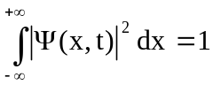.

There are many different ways to write the wavefunction describing a single simple (spinless) particle in 1D at some time: 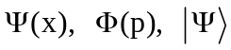 , and others, to be explained later. (Here x is position, and p is momentum).

If the particle has spin, then we have to include a spin coordinate m, in addition to the position coordinate in the wavefunction 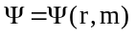. If the system has 2 particles, then the wavefunction is a function of two positions: 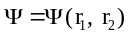.

Postulate 2 has to do with operators and observables and the possible results of a measurement. We will just skip that one for now!

Postulate 3 has to do with the results of a measurement of some property of the system and it introduces indeterminacy in a fundamental way.
It provides the physical interpretation of the wavefunction.

Postulate 3: If the system at time t has wavefunction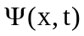, then a measurement of the position x of a particle will not produce the same result every time.
does not tell where the particle is, rather it give the probability that a position measurement will yield a particular value according to
= Probability (particle will be found between x and x+dx, at time t)

An immediate consequence of Postulate 3 is
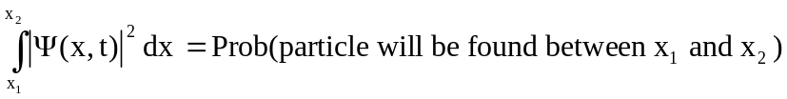

Since the particle, if it exists, has to be found somewhere, then
Prob(particle will be found between –∞ and +∞ ) = 1.
Hence the necessity that the wavefunction be normalized,

This QM description is very, very different from the situation in classical mechanics. In classical mechanics, the state of a one-particle system at any given instant of time is determined by the position and the momentum (or velocity): . So, a maximum of 6 real numbers completely describes the state of a classical single-particle system.
(Only 2 numbers, x and p, are needed in 1-D)
In contrast, in QM, you need a function 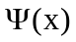. To specify a function, you need an infinite number of numbers. (And it's a complex function, so you need 2 × ∞ numbers!)

In classical mechanics, the particle always has a precise, definite position, whether or not you bother to measure its position.
In quantum mechanics, the particle does not have a definite position, until you measure it.

The Conventional Umpire: "I calls 'em as I see 'em."
The Classical Umpire: "I calls 'em as they are."
The Quantum Umpire: "They ain't nothing till I calls 'em."

In quantum mechanics, we are not allowed to ask questions like "What is the particle doing?" or "Where is the particle?" Instead, we can only ask about the possible results of measurements: "If I make a measurement, what is the probability that I will get such-and-such a result?"

QM is all about measurement, which is the only way we ever truly know anything about the physical universe.

Quantum Mechanics is fundamentally a probabilistic theory. This indeterminacy was deeply disturbing to some of the founders of quantum mechanics. Einstein and Schrödinger were never happy with postulate 3. Einstein was particularly unhappy and never accepted QM as complete theory. He agreed that QM always gave correct predictions, but he didn't believe that the wavefunction contained all the information describing a physical state. He felt that there must be other information ("hidden variables"), in addition to the wavefunction, which if known, would allow an exact, deterministic computation of the result of any measurement. In the 60's and 70's, well after Einstein's death, it was established that "local hidden variables" theories conflict with experiment. Postulates 1 and 3 are consistent with experment! The wavefunction really does contain everything there is to know about a physical system, and it only allows probabilistic predictions of the results of measurements.

The act of measuring the position changes the wavefunction according to postulate 4:

Postulate 4: If a measurement of position (or any observable property such as momentum or energy) is made on a system, and a particular result x (or p or E) is found, then the wavefunction changes instantly, discontinuously, to be a wavefunction describing a particle with that definite value of x (or p or E). (Formally, we say "the wavefunction collapses to the eigenfunction corresponding to the eigenvalue x." )
(If you're not familiar with this math terminology, don't worry - we'll discuss these words more soon)

If you make a measurement of position, and find the value x_{o}, then immediately after the measurement is made, the wavefunction will be sharply peaked about that value, like so:

(The graph on the right should have a much taller peak because the area under the curve is the same as before the measurement. The wavefunction should remain normalized. )

Postulate 1 states that the wavefunction is continuous. By this we mean that Ψ(x,t) is continuous in space. It is not necessary continuous in time. The wavefunction can change discontinuously in time as a result of a measurement.

Because of postulate 4, results of rapidly repeated measurements are perfectly reproducible. In general, if you make only one measurement on a system, you cannot predict the result with certainty. But if you make two identical measurements, in rapid succession, the second measurement will always confirm the first.
QM is infuriatingly vague about what exactly constitutes a "measurement". How do you actually measure position (or momentum or energy or any other observable property) of a particle? For a position measurement, you could have the particle hit a fluorescent screen or enter a bubble chamber. For a momentum or energy measurement, it's not so clear. More on this later.

For now, "measurement" is any kind of interaction between the microscopic system observed and some macroscopic (many-atom) system, such as a screen, which provides information about the observed property.

Postulate 5, the last one, describes how the wavefunction evolves in time, in the absence of any measurements.

Postulate 5. The wavefunction of an isolated system evolves in time according to the Schrödinger Equation:
where V = V(x) is the (classical) potential energy of the particle, which depends on the physical system under discussion.

One's first reaction to Postulate 5 is "Where did that come from?" How on earth did Schrödinger think to write that down? We will try to make this equation plausible (coming soon!) and show the reasoning that lead Schrödinger to this Nobel-prize-winning formula. But, remember, it's a Postulate, so it cannot be derived. We believe it is true because it leads to predictions that are experimentally verified.
Statistics and the Wave function.

Because QM is fundamentally probabilistic, let's review some elementary statistics.
In particular (to start) let's consider random variables that can assume discrete values.
Suppose we make many repeated measurements of a random discrete variable called x. An example of x is the mass, rounded to nearest kg (or height, rounded to the nearest cm) of a randomly-chosen adult.

We label the possible results of the measurements with an index i. For instance, for heights of adults, we might have x₁=25 cm, x₂ = 26 cm, etc (no adult is shorter than 25 cm). The list {x₁ , x₂, ... x_{i},... } is the called the spectrum of possible measurement results. Notice that x_{i} is not the result of the i^{th} trial (the common notation in statistics books). Rather, x_{i} is the i^{th} possible result of a measurement in the list of all possible results.

N = total # of measurements.
n_{i} = # times that the result x_{i} was found among the N measurements.

Note that 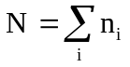 where the sum is over the spectrum of possible results, not over the N different trials.

In the limit of large N (which we will almost always assume), then the probability of a particular result x_{i} is 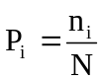 = (fraction of the trials that resulted in x_{i}).

The average of many repeated measurements of x = expectation value of x =
The average value of x is the weighted sum of all possible values of x: 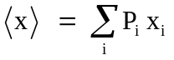
Again, this is called the expectation value of x (even though you might e.g. NEVER find any particular individual whose height is the average or "expected" height!)

We can generalize this result to any function of x:

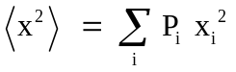 , 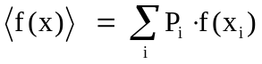
The brackets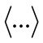 means "average over many trials". We would call this the "expectation value of x²".
A measure of the expected spread in measurements of x is the standard deviation σ, defined as "the rms average of the deviation from the mean".
"rms" = root-mean-square = take the square, average that, then square-root that.

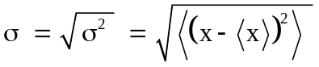 σ² is called the variance.
Let us disassemble and reassemble: The deviation from the mean of any particular result x is 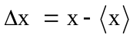. The deviation from the mean is just as likely to be positive as negative, so if we average the deviation from the mean, we get zero: 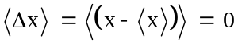.
To get the average size of 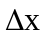, we will square it first, before taking the average, and then later, square-root it: 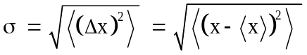
It is not hard to show that another way to write this is 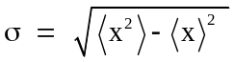.
There are times when this way of finding the variance is more convenient, but the two definitions are mathematically equivalent: Proof:

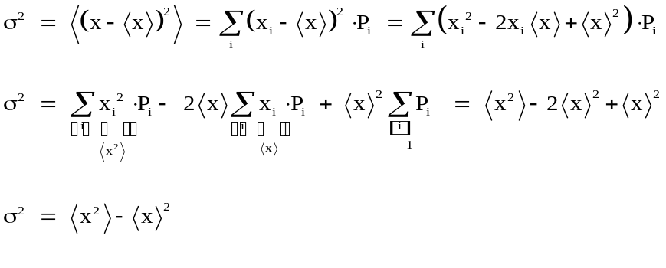
_________
Now we make the transition from thinking about discrete values of x (say x = 1, 2, 3, ...) to a continuous distribution (e.g. x any real number). We define a probability density ρ(x):

ρ(x) dx = Prob( randomly chosen x lies in the range x → x+dx )

In switching from discrete x to continuous x, we make the following transitions:
Please look again at these equations, (on left and right): think about how they "match up" and mean basically the same thing! (We'll use both sides, throughout this course.)
From Postulate 3, we make the identification 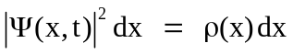and we have
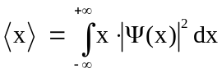
So in QM, the expectation value of the position (x) of a particle (with given wave function Ψ) is given by this (simple) formula for <x>. It's the "average of position measurements" if you had a bunch of identically prepared systems with the same wave function Ψ.
More generally , for any function f = f(x), we have 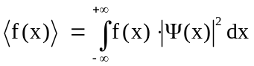.
Griffiths gives an example (1.1) of a continuous probability distribution. Let's redo that example, just slightly modified, to help make sense of it. (Take a look at it first, though)

A rock, released from rest at time t=0, falls a distance h in time T.
.
A move is taken as the rock falls (from t=0 → T), at 60 frames/sec, resulting in thousands of photos of the rock at regularly-spaced time intervals.
The individual frames are cut out from the film and then shuffled. Each frame corresponds to a particular x and t, and a particular dx and dt. (dx might show up visually as a smear, since the rock moved during the short time that picture frame was taken)
All frames have the SAME dt, but different frames have different dx's:
dx/dt = gt => dx = g t dt.

We can define the probability distribution in space, ρ(x), and the probability distribution in time, τ(t):
ρ(x)dx = Prob (frame chosen at random is the one at x → x+dx)
τ(t)dt = Prob (frame chosen at random is the one at t → t+dt)
dx
h
T
x
t
dx
dt
dt
Here's a little picture that might help:

(To be precise, I should really be writing Δx instead of dx, and Δt instead of dt. In the end, I'll take the limit Δt →0)
Notice all the dt's are the same size, but the dx's start out short and get longer and longer.

Now: τ(t)dt = dt/T , that is, τ(t) = constant = 1/T.
Convince yourself! That's because any random frame is equally likely to be at any given time (early, middle, late). So the probability τ(t) needs to be constant. But why is it 1/T? That's to ensure that the total probability of the frame being somewhere between 0 and T is exactly one:
Each frame is equally likely, and the probability of grabbing one particular frame is proportional to 1/T. (It is also proportional to dt, if the frames are all longer, there are fewer overall, and the probability scales accordingly. Convince yourself!)
If you pick a particular t and dt (i.e. some particular frame) then corresponding to that (t,dt) is a particular (x,dx).
The probability that that particular frame will be picked is what it is (all frames are equally likely, after all):
Prob(t → t+dt) = Prob(x t→ x+dx)
which means

But we know (see our kinematics equations above)
So

That's what Griffiths got (thinking about it slightly differently).
Check out his derivation too!
_____________

The key formula in this problem is
It is vital to remember that, when using this formula, x and t are not independent.
The x is the x which corresponds to the particular t
(and dx is the interval in x which corresponds to the dt of that "frame")

_____

By the way, you might be uncomfortable treating dx/dt as though it was just a fraction Δx/Δt. But, we often "pull apart" dx/dt and writ things like

, or
This makes sense if you remember that
To physicists, dx/dt really is a tiny Δx (dx) divided by a tiny Δt (dt).

Complex Number Review:

Wave functions Ψ are in general complex functions. So it's worth a quick review of complex numbers, since we'll be dealing with this all term.
Any complex number z can always be written in either
Cartesian form: z = x+iy or Polar form: z =

You can visualize a complex number by thinking of it
as a point in the complex plane:
This picture also matches up with one of the most important theorems of complex numbers, Euler's relation:
(Which can be proven w/ a Taylor Series expansion, if you like) This means that
Re[z] = x = A cosθ
Im[z] = y = A sinθ (Again, look at the picture above, do you see the connections?)
The complex conjugate of z is called z* = x-iy,
which is also z*=
Note that

We therefore call |z| = "modulus of z" or "amplitude of z", and define it as
Note that . Also notice that
Squaring complex numbers does NOT always yield a real result, and in general is quite different than multiplying by the complex conjugate. i.e. the square of a complex number is DIFFERENT from the square of the amplitude of that number.
Here's a useful fact:
(where z₁, z₂ are any 2 complex numbers)
This means in particular that
(which in turn can be used to derive various trig identities, like e.g. that
cos(a+b) = cos(a)cos(b)-sin(a)sin(b): just look at the real part of the equation)

Also, if then it is very quick and easy to find the product:

One more useful fact about complex numbers:
Any complex number z, written as a complicated expression, no matter how messy, can be turned into its complex conjugate z* by replacing every i with -i, so e.g.

__________________________

Classical Waves Review:

QM is all about solving a wave equation, for ψ(x,t). But before learning that, let's quickly review classical waves. (If you've never learned about waves in an earlier physics class - take a little extra time to be sure you understand the basic ideas here!)
A wave = a self-propagating disturbance in a medium.

A wave at some moment in time is described by
y = f(x) = displacement of the medium from its equilibrium position

Claim: For any function y=f(x), the function
y(x,t) = f(x-vt) is a (1-dimensional) traveling wave moving rightward, with speed v.
If you flip the sign, you change the direction. (We will prove the claim in a couple of pages, but first let’s just make sense of it)

Example 1: A gaussian pulse y = f(x) =
(If you are not familiar with the Gaussian function in the above equation, stare at it and think about what it looks like. It has max height A, which occurs at x=0, and it has "width" σ.
Sketch it for yourself, be sure you can visualize it. It looks rather like the form shown above)
A traveling gaussian pulse is thus given by y(x,t) = f(x-vt) = .

Note that the peak of this pulse is located where the argument of f is 0, which means (check!) the peak is where x-vt=0,
in other words, the peak is always located at position x=vt.
That's why it's a traveling wave!

Such a wave is sometimes called a “traveling wave packet”, since it’s localized at any moment in time, and travels to the right at steady speed.
Example 2: A sinusoidal wave y = f(x) =
(This one is probably very familiar, but still think about it carefully. )

“A” is the amplitude or maximum height.
The argument changes by 2π, exactly one "cycle", whenever x increases by λ. (That's the length of the sin wave, or "wavelength", of course!)
Now think about the traveling wave
y(x,t) = f(x-vt) - try to visualize this as a movie - the wave looks like a sin wave, and slides smoothly to the right at speed v. Can you picture it?)

Review of sinuosoidal waves:
For sine waves, we define k = = "wave number". (k has units "radians/meter")
k is to wavelength as angular frequency (ω) is to period, T.
Recall (or much better yet re-derive!) = angular frequency = rads/sec
Remember also, frequency f = # cycles/ time = 1 cycle/(time for 1 cycle) = 1/T.

In the previous sketched example, (the traveling sin wave)
y(x) = A sin(kx) => y(x,y) = A sin(k(x-vt))
Let's think about the speed of this wave, v.
Look at the picture: when it moves over by one wavelength, the sin peak at any given point has oscillated up and down through one cycle, which takes time T (one period, right?)
That means speed v = (horizontal distance) / time = λ / T = λ f
So the argument of the sin is
(Don't skim over any of that algebra! Convince yourself, this is stuff we'll use over and over)
Summarizing: for our traveling sin wave, we can write it several equivalent ways:
The argument of the sign changes by 2π when x changes by λ, or t changes by T.
The wave travels with speed v = λ / T = ω/k. (We’ll use these relations all the time!)
Please check units, to make sure it’s all consistent.

Technically, this speed v =ω/k is called the phase velocity, because it’s the speed at which a point of constant phase (like say the “zero crossing” or “first peak” or whatever) is moving.

Soon we will discover, for some waves, another kind of velocity, the group velocity. Never mind for now!)

I said that f(x-vt) represents a traveling wave – it should be reasonable from the above pictures and discussion, but let’s see a formal proof – (next page)
________________________________________________________

Claim: y(x,t) = f(x ± vt) represents a rigidly shaped ("dispersionless") traveling wave.
The upper "+" sign gives you a LEFT-moving wave.
The - sign is what we've been talking about above, a RIGHT-moving wave.

Proof of Claim:
Consider such a traveling wave, moving to the right, and then think of a new, moving coordinate system (x',y'), moving along with the wave at the wave's speed v.

Here, (x,y) is the original coordinate system,
And (x’,y’) is a new, moving coordinate system, traveling to the right at the same speed as the wave.

Let’s look at how the coordinates are related:
Look at some particular point (the big black dot).
It has coordinates (x,y) in the original frame.
It has coordinates (x',y') in the new frame.
But it's the same physical point.
Stare, and convince yourself that
x=x'+vt, and y=y'
That's the cordinate transformation we’re after, or turning it around,
x'=x-vt, and y'=y

Now, in the moving (x',y') frame, the moving wave is stationary, right? (Because we're moving right along with it.) It's very simple in that frame:
(In this frame, the (x,y) axes are running away from us off to the left at speed v, but never mind…)
The point is that in this frame the wave is simple, y'=f(x'), at all times.
It just sits there!
If y'=f(x'), we can use our transformation to rewrite this
(y'=y, x'=x-vt), giving us y=f(x-vt).
This is what I was trying to prove: this formula describes the waveform traveling to the RIGHT with speed v, and fixed "shape" given by f.
In classical mechanics, many physical systems exhibit simple harmonic motion, which is what you get when the displacement of a point object obeys the equation F = -kx, or
. (Hopefully that looks pretty familiar!)
If you have a bunch of coupled oscillators (like a rope, or water, or even in free space with oscillating electric fields), you frequently get a related equation for the displacement of the medium, y(x,t), which is called the wave equation.
In just one spatial dimension (think of a string), that equation is .
(If you’re curious, go back to your mechanics notes, it’s likely you spent a lot of time deriving and discussing it!)

Theorem: Any (1D) traveling wave of the form y(x,t) = f(x ± vt) is a solution of the wave equation above.

Proof: We are assuming y(x,t) = f(φ), where φ=φ(x,t) = x-vt, and we're going to show
(no matter what function, f(φ), you pick!) that this y(x,t) satisfies the wave equation.

. This is just the chain rule, (and I used the fact that .)
(Please make sense of where I write partials, and where I write full derivatives)
Now do this again:
(1) (Once again using )

Similarly, we can take time derivatives, again using the chain rule:
(here I used the fact that , you see why that is?)
And again, repeat the time derivative once more:
(2)
Using (1) and (2) to express two different ways gives what we want:

That last equality is the wave equation, so we're done.

Again: ANY 1-D traveling wave of the form f(x ± vt) solves the wave equation, and the wave equation is just a very basic equation satisfied by MANY simple, linear systems built up out of coupled oscillators (which means, much of the physical world!)
Example 1: Maxwell's equations in vacuum give (where "E" can be E_y or E_z here) and v = = c, the speed of light, 3E8 m/s.
So we’re saying that EM waves do NOT have to be "sinusoidal waves": they can be pulses, or basically any functional shape you like - but they will all travel with the same constant speed c, and they will not disperse (or change shape) in vacuum.

Example 2:
A wave on a 1-D string will satisfy , where y represents the displacement of the rope (and x is the position along the rope), and the speed is given by .
So here again, on such a string, wave pulses of any shape will propagate without dispersion (the shape stays the same), and the speed is determined NOT by the pulse, but by the properties of the medium (the rope - it's tension and mass density)
________________________________________________

Superposition Principle: If y1(x,t) and y2(x,t) are both separately solutions of the wave equation, then the function y1+y2 is also a valid solution.

This follows from the fact that the wave equation is a LINEAR differential equation. (Look back at the wave equation, write it separately for y1 and y2, and simply add)

We can state this a little more formally, if

Here, we are defining a linear operator L, which does something to FUNCTIONS:

The key properties for any linear operator are that
and
(for any constant c)

Reminder: Functions are things which take numbers in, and give out numbers, like f(x) = y.
Here x is the "input number", and y is the "output number". That's what functions ARE.

Now we have something new (which will reappear many times this term), we have an operator, which takes a function in and gives a function out.

(Here y(x) was the input function, the operator operates on this function, and gives back a different function out, g(x).
Wave Nature of Light, and Interference

Because of the superposition principle, waves add just as you would expect. That is, if you send two waves "down a string", they just add (or cancel) as simply as y(total) = y1+y2.

This leads to constructive and destructive interference, one of the defining characteristic properties of waves. Following, you will find some notes from a freshman course reviewing interference, in case you’ve forgotten. (For instance, how is that you get an interference pattern from two slits?) The math and physics here will apply directly in quantum mechanics, because particles also exhibit wavelike behaviour.

In general, wave-like effects with light are difficult to detect because of the small wavelength of visible light (400 nm (violet) → 700 nm (red)) The problem is even tougher with particles, it requires very special circumstances to demonstrate the wave nature of matter.
So, in many situations, light behaves like a ray, exhibiting no obvious wave-like behavior.

Newton (late 1600's) did not believe that light was a wave since he always observed ray-behavior. Wave-like behavior was not clearly observed until around 1800, by Young.
Wave-like behavior of particles was not clearly observed until around 1925, in Davisson and Germer's experiment (using a crystal of nickel as a "grating")

Review of Constructive/Destructive interference of Waves:
Consider 2 waves, with the same speed v, the same wavelength λ, (and therefore same frequency f = c / λ ), traveling in the same (or nearly the same) direction, overlapping in the same region of space:
If the waves are in phase, they add ⇒ constructive interference

If the waves are out of phase, they subtract ⇒ destructive interference

If wave in nearly the same direction:
plane wave
λ
spherical wave (same λ, f )
speed c
c
c
wall with infinitesimal hole

Huygen's Principle: Each point on a wavefront (of given f, λ ) can be considered to be the source of a spherical wave.

To see interference of light waves, you need a monochromatic (single λ) light source, which is coherent (nice, clean plane wave). This is not easy to make. Most light sources are incoherent (jumble of waves with random phase relations) and polychromatic (many different wavelengths).
Young's Double slit experiment (1801) :

What do you expect to see on the screen? If you believe light is a ray, then you expect to see 2 bright patches on the screen, one patch of light from each slit.
position x
on screen
Intensity I
d
But here is what you actually see: A series of bright and dark fringes: wave interference
x
I

How do we explain this? Consider the 2 slits as 2 coherent point sources of monochromatic light. Two sources are coherent is they have the same wavelength λ (and therefore the same frequency f ) and they emit peaks and troughs in sync, in phase.

Each slit (source) emits light in all forward directions, but let us consider only the parts of the waves heading toward a particular point on the screen.

If the screen is far away (L >> d), then the rays from the two slits to the same point on the screen are nearly parallel, both heading in the same direction, at the same angle θ.

The ray from the lower slit has to travel further by an extra distance (d sinθ) to reach the screen. This extra distance is called the path difference. When the path difference (p.d.) is one full wavelength, or 2 full wavelengths, or an integer number of wavelengths, then the waves will arrive in phase at the screen. There will be constructive interference and a bright spot on the screen.
, m=0,1,2,…. (constructive interference)
But if the path difference is ½ wavelengths or 3/2 wavelengths, etc, then there will be destructive interference at the screen and the screen will be dark there.
, m=0,1,2,…. (destructive interference)
Notice that the formula p.d. = d sinθ is NOT a definition of path difference. It is a formula for path difference in a specific situation, namely when the screen is "at infinity".
The definition of path diff. is: p.d. = (distance to one source) – (distance to other source)
A plot of brightness (intensity) vs. angle position on the screen:

Maxima at angles where sinθ = m λ / d ≅ θ (rads) [Recall sinθ ≅ θ (rads) if θ << 1]
Young's experiment was the first real proof that light is a wave. If you believe that light is a ray, there is no way to explain the destructive interference seen on the screen. In the ray-view, when you hit a screen with two rays, the brightness of the 2 rays always adds and you see a bright spot there. It is impossible to explain destructive interference of two light sources, unless you admit that light is a wave. The same thing happened in the 1920's with Davisson and Germer's experiments with electron diffraction, here with the even more bizarre conclusion that forces you to admit that electrons are "waves" too!

Single Slit Diffraction
D
slit filled with imaginary Huygen's sources
"Diffraction" = interference due to infinitely-many sources packed infinitely close via Huygen's Principle. Huygen's Principle says that a slit that is illuminated by a plane wave can be consider to be filled with an array of coherent point sources.

Consider the light from just two of the infinitely-many sources: one at the top of the slit, and one exactly in the middle of the slit. When the path difference between these two sources and the screen is ½ wavelength, that is, when , then the light from these two source interfere destructively and no light from those two sources illuminates the screen at that particularly angle θ.
D
θ
θ
θ
(D/2) sinθ
to screen
D/2
But notice that all the sources can grouped in pairs, with each pair's members D/2 apart. The light from all the sources (the entire slit) cancel in pairs, and there is no light at the position on the screen at the angle θ such that . The angle is the first intensity minimum on the screen.
D/2
D/2
The intensity pattern on the screen looks like this:

The angular width of the "central maximum" is .
Notice that in the limit, D → λ (slit width becomes as small as the wavelength of light), the central max becomes so broad, that we get spherical wave behavior.
λ
D > λ

λ
D ≈ λ

Diffraction Grating
A diffraction grating is an array of many narrow slits with a uniform inter-slit spacing d.
A grating with "500 lines per cm" has a slit separation of 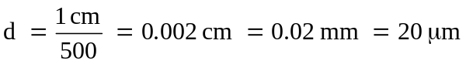
d
θ
d sinθ
grating
A typical diffraction grating has thousands of slits. With exactly the same argument we used in the double-slit case, we see that maximum brightness occurs when
, m=0,1,2,….
The maxima occur at the same angles as with a double slit of the same d, but the peaks are much sharper and much brighter.
As N (the number of slits) increases, the width of each peak decreases (and gets brighter). Why?

With just 2 slits, when we are near the maximum at the angle θ = λ / d, then the waves from the two slits are nearly in phase and we have nearly complete constructive interference and nearly maximum brightness. But with N-slits, when we are near the angle θ = λ / d, any two adjacent slits are nearly in phase, but the next slit over is a little more out of phase, and the next one over is even more out of phase. With many slits, if you are just a bit off the special angle for maximum brightness, the phase differences among the slits quickly add up and gives destructive interference. Another nice feature of the grating is that, with many slits for the light to get through, the pattern on the screen is brighter than in the double-slit case
A Brief History of Modern Physics
and the development of the Schrödinger Equation

"Modern" physics means physics discovered after 1900; i.e. twentieth-century physics.

1900: Max Planck (German) tried to explain blackbody ("BB") radiation (that's radiation from warm objects, like glowing coals) using Maxwell's equations and statistical mechanics and found that he could not. He could only reproduce the experimentally-known BB spectrum by assuming that the energy in an electromagnetic wave of frequency f is quantized according to
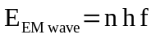, where n = 1, 2, 3, … and h = Planck's constant = 6.6×10⁻³⁴ (SI units)
Planck regarding this as a math trick; he was baffled by its physical significance.

1905: Albert Einstein, motivated in part by Planck's work, invents the concept of a photon (though the name "photon" came later!) to explain the photoelectric effect.
A photon is a quantum (packet) of electromagnetic radiation, with energy

Note the definition of =1.05x10⁻³⁴ J s = 6.6x10⁻¹⁶ eV s (Called "hbar")

1911: Ernest Rutherford (New Zealand/Britain) shows that an atom consists of a small, heavy, positively-charged nucleus, surrounded by small light electrons. But there is a problem with the classical theory of this nuclear atom: An electron in orbit about a nucleus is accelerating and, according to Maxwell's equations, an accelerating charge must radiate (give off EM radiation). As the electron radiates, giving energy, it should spiral into the nucleus.

1913: Niels Bohr (Danish), a theorist working in Rutherford's lab, invents the Bohr model. This is essentially a classical model, treating the electron as a particle with a definite position and momentum, but the model has two non-classical, ad hoc assumptions:
Classically, an electron in an atom should radiate and spiral inward as it loses energy.
1) The angular momentum of the electron is quantized: 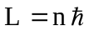 .
2) The electron orbits, determined by (1), are stable ("stationary"), do not radiate, unless there is a transition between two orbits, and then the atom emits or absorbs a single photon of energy 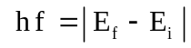

The predictions of Bohr model match the experimental spectrum of hydrogen perfectly.

It is important to remember that the Bohr model is simple, useful, and wrong. For instance, it predicts that the ground state of the H-atom has angular momentum 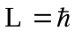 , when in fact, the ground state of the H atom (s-state) has L = 0. The Bohr model is a semi-classical model, meaning it combines aspects of classical and quantum mechanics. Semi-classical models are frequently used by physicists because they are heuristically useful (easy to understand and often give correct results). But they must always be used with extreme care, because the microscopic world is really purely quantum. We insert classical mechanics into the microscopic world not because it is correct, but because it is convenient.

1922: Louis de Broglie (French) proposes wave-particle duality. Theory and experiment indicate that waves sometimes act like particles (photons). Perhaps, argues de Broglie, particles can sometimes act like waves. For photons: 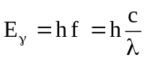 .
According to Special Relativity (and Maxwell's equations) light of energy E carries momentum 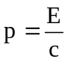. Hence, 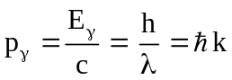.
De Broglie argues that the same equations apply to particles and introduces the idea of matter waves.

de Broglie relations: 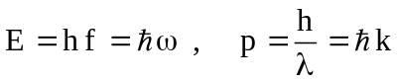

De Broglie's hypothesis provides a nice explanation for Bohr's quantization condition :
assuming that an integer number of wavelengths fit in one orbital circumference (the condition for a standing wave), we have
n = 5
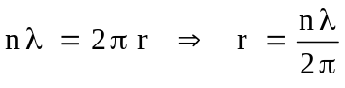
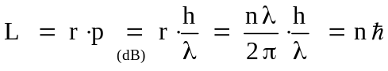

Soon, there was indisputable experimental verification of the photon concept and of the de Broglie relations. In 1923, the American Arthur Holly Compton observes the Compton Effect, the change in wavelength of gamma-rays upon collision with electrons. This effect can only be explained by assuming that gamma-rays are photons with energy 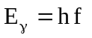and momentum 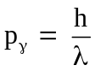.
Then, in 1927, Americans Davisson and Germer diffract a beam of electrons from a nickel crystal, experimentally verifying that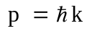 for electrons.
Late in 1925, Erwin Schrödinger, then Professor of Physics at Zurich University, gives a colloquium describing de Broglie's matter wave theory. In the audience is physicist Peter Debye, who called this theory "childish" because "to deal properly with waves, one has to have a wave equation". Over Christmas break, Schrödinger begins developing his equation for matter waves.
1927: Erwin Schrödinger (Austrian) constructs a wave equation for de Broglie's matter waves. He assumes that a free particle (potential energy = V = 0) is some kind of wave described by

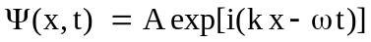

{ Recall Euler's relation: 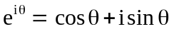, so .}
Initially, Schrödinger works with a complex wavefunction purely for mathematical convenience. He expects that, in the end, he will take the real part of Ψ to get the physically "real" matter wave. )

The energy of this free particle is all kinetic so 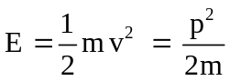.
According the de Broglie relations, this can be rewritten:
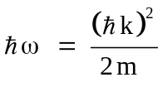
Schrödinger searches for a wave equation that will reproduce this energy relation. He notes that

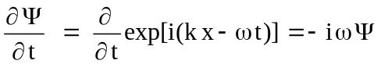 and 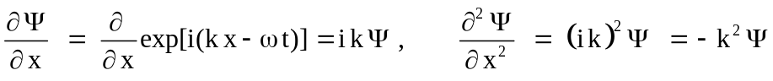 so ...
the (trial) equation

This looks promising. To describe a particle with both KE and potential energy V = V(x), Schrödinger added in the term V⋅Ψ , producing finally

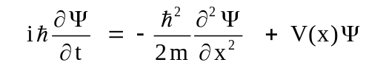

The Schrödinger Equation is really an energy equation in disguise. When you look at the S.E., you should try to see E = KE + PE. For a particle with frequency f (energy E = h f ) and wavelength λ (momentum p = h/λ ) in a potential V, this equation appears to correctly predict that 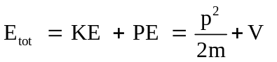which (according to de Broglie) is 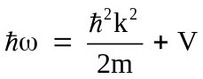

This "derivation" is merely a plausibility argument. Schrödinger immediately used the equation to solve for the energies in a hydrogen atom and found that he got the right answer for the energy levels.
This gave him confidence that the equation was correct.
The physicist Paul Dirac famously asserted that the Schrödinger Equation accounts for "much of physics and all of chemistry". It is probably the most important equation of the 20th Century. Its effect on technological progress has been much, much greater than the more famous equation E = mc².
Schrödinger was quite puzzled by the nature of the wave function. What is the physical meaning of Ψ(x,t)? He wanted to think of it as some kind of physical matter wave, like an electromagnetic wave E(x,t). But this interpretation could not explain a host of experimental results, such as that fact that a particle with a large extended wave function is always found at one small spot when a position measurement is made.

It was German theorist Max Born, who late in 1927 proposed that the wave function is a kind of information wave. It provides information about the probability of the results of measurement, but does not provide any physical picture of "what is really going on." Bohr, Heisenberg, and others argued that questions like "what is really going on" are meaningless. Humans live at the macroscopic level, excellently described by classical mechanics, and our brains evolved to correctly describe macroscopic (classical) phenomena. When we ask "what is going on", we are really asking for an explanation in terms that our brains can process, namely, a classical explanation. The microscopic world is fundamentally different from the classical world of large objects that we inhabit, and our brains' internal models simply don't apply at the level of atoms. There may be no hope of understanding "what is really going on" in atoms because our brains are not built for that job. All we can know are the results of measurements made with macroscopic instruments.

This view, that the wave function provides probabilistic information, but not a physical picture of reality, is part of the "Copenhagen interpretation" of Quantum Mechanics (so-called because it was largely developed at Bohr's research institute in Copenhagen.) Einstein, de Broglie, Schrödinger himself, and others were very dissatisfied with this view, and they never accepted the Copenhagen interpretation.

Nobel Prizes for QM

Many of the pioneers of QM eventually received Nobel Prizes in Physics

1918 Max Planck, concept of energy quanta
1921 Albert Einstein, photon concept and explanation of photoelectric effect
1922 Niels Bohr, Bohr Model
1926 James Franck and Gustav Hertz, Franck-Hertz experiment showing quantization of atomic levels
1927 Arthur Compton, Charles Wilson, Compton effect, Wilson cloud chamber
1929 Louis de Broglie, wave-particle duality
1932 Werner Heisenberg, Uncertainty Principle and Matrix formulation of QM
1933 Erin Schrödinger and Paul Dirac, Formulation of QM
1937 Clinton Davisson and George Thomson, experimental discovery of electron diffraction
1945 Wolfgang Pauli, exclusion principle
1954 Max Born, interpretation of the wave function
…

- Ernest Rutherford received the 1908 Nobel prize in chemistry for experimental investigations of radioactive decay, but never received the prize for discovery of the nuclear atom.
- Albert Einstein never received the prize for either Special or General Relativity.

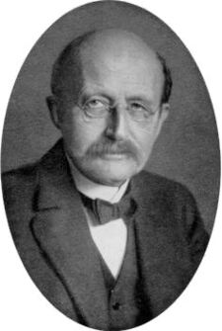
Max Planck, German, 1858-1947

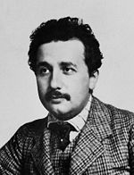

Albert Einstein, German-Swiss-American, 1879-1955



Ernest Rutherford, New Zealand-British, 1871-1937

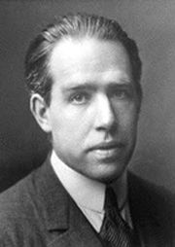

Niels Bohr, Danish, 1885-1962

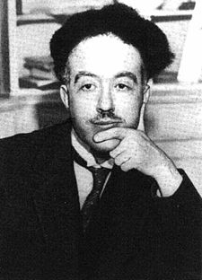

Louis de Broglie, French, 1892-1987

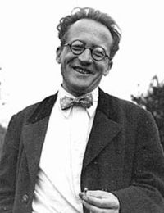

Erwin Rudolf Josef Alexander Schrödinger, Austrian,
1887-1961
Comment on numbers and scales: QM involves solving partial differential equations (or matrix equations, or operator equations) which can at times be mathematically formidable, but in many cases, understanding the simple relations described in the sections above, and knowing the basic units and numerical constants, is enough to give you a sense for a lot of physics.

Simple relations to remember:
All waves: (wavelength * frequency = speed of wave. For light, v=c = 3x10⁸ m/s)
Light: E=hν (energy of photon is Planck's constant times frequency)
= (same, just convert frequency, ν, to angular frequency, ω, by )
deBroglie relations ("matter waves")
(p is momentum, lambda=wavelength of the matter wave, is the "wave number")
Einstein: E=mc² (only for objects at rest, otherwise use )
It's amazing how much back of the envelope physics you can do with freshman physics, plus these!

Common numbers and constants:

You can always look up constants (and you should locate your favorite collection!) but having a few common constants at your fingertips is really pretty handy.
Still, (e.g.) =1.05x10⁻³⁴ J s is a number which I often forget (it's so small!)
The combination of this constant times the speed of light, = 2000 eV Angstroms (roughly) is somehow a simpler number for me to remember. And this combination occurs often!
• An Angstrom is 10⁻¹⁰ m, or 0.1 nm, a very convenient distance in atoms, since that happens to be the typical size of atomic orbits.
• An eV is not a standard SI energy unit, but this one I always seem to remember from E&M:
1eV = 1.6x10⁻¹⁹ J is a typical atomic energy scale. It's the energy gained when an charge "e" (like a proton, or electron) moves through a potential difference of 1 Volt)
You use eV a lot in practical atomic problems.

Remember from E&M that electrical potential energy of two charges a distance r apart is ,
which tells us (using q=e) that has units of energy*distance, the exact SAME units as (!)
Sure enough, the following combination of constants (which is thus UNITLESS, a pure number) appears over and over in physical problems: = 1/137.
This is called the "fine structure constant of nature".
Another combination which you often see is
=511 keV (where m is the electron mass, and c the speed of light. By E=mc^2, this must have units of energy)
If you solve a problem and the answer does NOT have such a combination of constants, you might "multiply and divide" by some power of c (or ) to GET this combination, so you can then just "remember" the answer. I can't tell you how much calculator grief this has saved me over the years.

Slightly silly Example: How many photons does an ordinary lightbulb emit each second?

This is a highly complex (and ill-defined!) problem, but we can make a simple, crude estimate by making some simplifying assumptions.
1) Assume light from a bulb is visible, in the middle of the spectrum (yellow).
You would then have to go look up the wavelength of visible light, it's about 6000 Angstroms.
2) Assume that all the energy is going into visible light (ok assumption for a fluorescent bulb).
You would then have to go look up the power of a bulb, though you can probably guess that's about 100W for a bright one.
Each individual photon has energy E=hν, and so the total power (100 J/s) must be producing a total of 100 J/s / (hν Joules/photon) That's it, that's how many photons/sec should come out.
Now, ν=c/λ (which is handy, because λ=6000 Angstroms was what I looked up)
And 1eV = 1.6x10⁻¹⁹ J converts us to a more "photonic" energy scale
So the answer is
100 J/s / (1. 6x10⁻¹⁹ J/eV) * λ / hc, and then multiplying top and bottom by 2 π, I get
(200π / 1. 6x10⁻¹⁹) * (λ / ), and now I put in λ=6000 Angstroms, and = 2000 eV Angstroms, to get about 10²² photons each second.
No wonder we never notice or care that they're discrete, that's a huge number!

Slightly less silly Example: What energy should electrons have if you want to do an experiment to demonstrate their "wave nature"?

I am thinking that "showing wave nature" means generating some sort of interference, and for THAT, you need to have a wavelength comparable to a "slit size".
The smallest slit I can imagine is ONE atom wide (imagine bouncing electrons off a crystal, they can bounce off of one atom, or its neighbor, and those two "sources" will interfere).
Thus, without doing any hairball calculations, I would roughly want
λ(electron) = atomic size = 1 Angstrom. (or so)
DeBroglie then tells me I want the electron to have momentum .
And the energy associated with that momentum will be the good old freshman kinetic energy formula, E = p²/2m. So E = . That's it, I could plug in numbers!
But I can also multiply top and bottom by c^2, and divide top and bottom by (2 pi)^2, to get
E = (this is the SAME formula but now has combinations of constants I remember!)
This I can do in my head. π^2 is about 10, so I have (without a calculator!)
E = 4*π^2 *(2000 eV Angstrom)^2 / 2 (511 keV)(1 Angstrom)^2
That’s about 40*4*10^6 eV^2 / (1000 * 1000 eV) = 160 eV.
Anything LOWER than that will have a smaller momentum, or LONGER wavelength, and will diffract even better. So that's an upper bound. You don't need a high voltage supply for this!
(This is the basic physics of the Davisson and Germer experiment that first showed that deBroglie was not off his rocker!)

