The Formalism of Quantum Mechanics:

Our story so far …
- State of physical system: normalizable Ψ( x, t )

- Observables: operators

- Dynamics of Ψ: TDSE

To solve, 1st solve TISE:

Solutions are stationary states ψ_{n}(x), E_{n} ═►special solutions of TDSE:

TDSE linear ═►any linear combo. of solutions is also a solution.

Discrete case:

Continuum case:

Discrete
Discrete
Continuum
Discrete + Continuum

ψ_{n}'s , ψ_{k}'s form complete, orthonormal sets:

Notice similarity of Ψ 's to vectors;

- Vector // complex function Ψ( x, t )

- Scalar real number a // complex number c

- Any linear combination of vectors is a vector
//

- Orthonormal basis vectors
//

//

//

- Inner product
//
The space of all complex, square-integrable functions Ψ(x) is called Hilbert Space.

- Norm //

Hilbert Space is an infinite-dimensional vector space with complex scalars and normalizable vectors.

Postulate 1: Every possible physical state of a system corresponds to a normed vector in Hilbert Space. The correspondence is 1-to-1 except that vectors that differ by a phase factor (scalar of modulus 1) corresponds to the same state Ψ( x, t ) ◄═► e^{iθ} Ψ( x, t )

Dirac Notation:

=>

c any complex number:

Postulate 2: (to be stated shortly!) associates with every observable a linear, hermitean operator. But first, a little background:

Definition: An operator is hermitean (or hermitian, both spellings are common) if
Which can be written (in position representation) as

Question: Is the operator Hermitian? (The answer will be no.)
Let’s see why!

So the answer is NO, there’s an extra unwanted minus sign that cropped up. It is NOT the case that for this particular operator, that . Instead, we found here and that means Q is NOT hermitian.

By the way, the “surface turm” in our integration by parts gave me zero because f and g belong to Hilbert space, and thus should vanish off at infinity (so they’re normalizable!)
Question: Is the operator hermitian? Answer is Yes! Let’s see why:

Question: Is the operator hermitian (if c is some constant?)
It depends! This operator is hermitian only if c is real.

Why are hermitean operators special? Why only hermitean operators associated with physical observables? Because hermitean operators produce real eigenvalues (and measurements of observables always produce real values).

Eigenvalue equation:

eigenfunction eigenvalue

Theorem: The eigenvalues of a hermitean operator are real.

Proof: Assume f(x) is an eigenfunction:

Theorem: The eigenfunctions of a hermitean operator with distinct (different) eigenvalues are orthogonal.

Proof: Given

Postulate 2: (Operators + Observables) This is a long postulate with 3 parts, and many texts break this up into 2 or 3 postulates.

- For every physical observable Q (x, p, E, etc.) there corresponds a linear hermitean operator in the Hilbert Space which possesses a complete, orthonormal set of eigenfunctions f_{n} (x) and the corresponding eigenvalues q_{n}

- The only possible results of a measurement of Q are one of the eigenvalues q_{n}={q₁, q₂, q₃, …}

- The momentum operator is
The position operator is

Any function Q( x, p ) has operator

An example of is the energy operator (or Hamiltonian),

Solutions of form an orthonormal set (since is hermitian!)

That ψ_{n}'s form a complete set can be proven in some special cases like the infinite square well or S.H.O., but in general, completeness is taken as a postulate.

If energy is measured, the only possible result is one of the E_{n}'s.

*

The momentum eigenstates are solutions of:

Eigenfunctions:

Eigenvalues: (k any real number)

Proof: . (That’s it!)

In this case, the eigenvalues of p form a continuum (any real value of is permitted) and this leads to some mathematical subtleties.

Are the f_{p}'s orthonormal? (Ans: kind of … yes)

"Delta function orthogonality"

Adjust A so that <f_{p'} | f_{p} > = δ ( p – p' )

Thus, for any real p, ( + ) or ( - )

Question: are the f_{p}'s a complete set?

Fourier Analysis (Planchevel's Theorem) says that any f(x) can be written
Now, any Ψ ( x, t ) is a function of x (at arbitrary t), and thus (from the previous page)

A quick change of variables, , leads us to define

Putting it all together:
No subscript

Note! Previously we wrote similar relations when Ψ (x, t) was a free particle state
(V= 0). But any function Ψ (x, t) can be Fourier analyzed. In the special case of free particle, then

but this particular (simple) time-dependence in Φ(k, t) is true only for the special case of a free particle.

Φ(p, t) is called the momentum-space wave function. It is the Fourier transform of Ψ(x,t)

and tells "how much " is in Ψ. Φ(p, t) contains all the same info as Ψ(x,t).

*

We’re ready now to re-state Postulate 3. Previously, Postulate 3 was stated as

Prob ( find position in x → x + dx) = | Ψ |² dx.

Our re-statement will look very different, but will be same.

Postulate 3: If a system is in state Ψ(x,t), and a measurement of observable Q is made

on the system, where the corresponding operator has eigenfunctions f_{n}(x) and eigenvalues q_{n}:
, then the strongest predictive statement that can be made about the result of that measurement is:
Prob ( measure q_{n} ) = | < f_{n} | Ψ > |² (discrete spectrum)

If spectrum is continuous, (with any real value of q) then

Prob ( measure q_{n} → q + dq ) = | < f_{q} | Ψ > |² dq

*

Example of Postulate 3:
Suppose a system has discrete energy eigenvalues:

and your system is in a state that is a linear combo

then a measurement of energy will yield value E_{n} with probability =

| < ψ_{n} | Ψ > |² = | c_{n} |²

If the system is already in a particular (single, pure) eigenstate n₀:

then measurement of energy will yield E_{n0} with probability

This means an eigenstate of energy is state of definite energy. (Look back, think about it, convince yourself! The formalism can look opaque, but if you have an eigenstate of H, there is only ONE TERM in our expansion, and there is thus only one possible result when you measure energy)

A similar argument applies to any observable: an eigenstate of is a state of definite Q (and the value of Q = the eigenvalue of the eigenstate)

*

Previously, we asserted that the expectation value of Q =
. (We’ve used this, in the “integral form”, many times!)

We can now show this follows from Postulate3:

= weighted average of q_{n}'s.
( This is what you would mean by “the expectation value” of measurements of Q. )
Eigenstates of = states of definite energy

Eigenstates of = states of definite momentum

Eigenstates of = states of definite position
Ψ
x₀
x
Must be delta
function
Let’s look at these position eigenstates

variable x particular x = x₀

═> g(x) is zero everywhere, except at x = x₀
Notation: g_{x0}(x)

Postulate 3 says Prob ( x₀ → x₀ + dx) = | <x₀ | Ψ (x,t) >|² dx

(agrees with our previous version of Postulate 3, what we’ve been using all along).

Postulate 4: (Wave function collapse)
If a measurement of observable Q gives result q_{n}, then the wavefunction instantly collapses into the corresponding eigenfunction of Q, f_{n} (x).

Discrete spectrum example:

(where is an eigenstate of

Continuous spectrum example:

|Φ(p₀)|^2 is the probability density, telling you the probability if you measure momentum, that you will get p within p₀ → p₀ + Δp.
No measurement of continuous variable has infinite precision. Precision Δp depends on measurement. This means that in practice, collapse is to a normalizable Ψ that is almost an eigenstate
p
Δp
p₀
Φ(p,t)

After collapse:

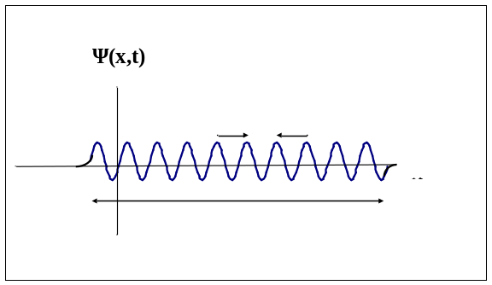

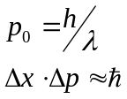

(uncertainty principle)

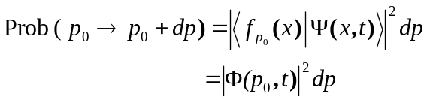

*

Function
Space
Hilbert Space
(Normalizable fcns)
all other
non-normalizable fcns

Eigenfunctions of
Hermitean operators
w/ continuous eigenvalues
(e.g. x, p)
(sol'ns of SE that are non-normalizable, but useful)

"Suburbs of H-space"

"Nearly normalizable =
δ-function normalizable"

To make our list of postulates complete:

Postulate 4: (Schrödinger Equation): The time evolution of the wavefunction Ψ(x,t) is determined by the TDSE:

________________________________________

To solve TDSE: Separation of variables =>
special solutions

General solution to TDSE:

(ψ_{n}'s form complete orthonormal set, since is hermitean!)

Any hermitean operator associated with an observable has a complete orthonormal set of eigenfunctions, but the energy eigenfunctions are special in that they provide the time-dependence of Ψ (x,t).

Comment about probabilities and normalization: consider normalized basis states ψ_{n}(x) and un-normalized Ψ = c₁ψ₁ + c₂ ψ₂. Note that <Ψ | Ψ > = | c₁ |² + | c₂ |² ≠ 1 . In this case, postulate 3 should read:
(You must divide by <Ψ | Ψ > for probabilities to add up to 1)

_________________________________________

Review to this point:

System Ψ (x,t). Measure Q.

Post3: Find q_{n} with

Post4: Ψ (x,t) → f_{n} (x)
collapse!

is "projection of Ψ onto f_{n} (x)"

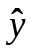
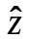
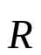
R_{x}

Euclidean space

Hilbert Space is a complex, infinite-dimensional vector space.
Basis states: ψ_{n} from
ψ₁
ψ₂
ψ₃
ψ_{n}

Any wavefunction

complex numbers

all
perpendicular: <Ψ_{n |} Ψ_{m} > = δ_{nm}

ψ₁
ψ₂
Ψ= c₁ ψ₁ + c₂ ψ₂
c₁ = <ψ₁ | Ψ>
c₂ =
<ψ₂ | Ψ>

a "poetic
representation"

: c_{n} tells how much of Ψ is along ψ_{n} axis in H-space

We have now seen 3 different equivalent ways to represent the wavefunctions:

{ c_{n} } looks different than functions Ψ and Φ, but not really: { c_{n} } is an infinite set of numbers that associate a number ( c_{n} ) with a "coordinate" n.
Likewise Ψ(x,t) is ∞ set of numbers that associate a number Ψ(x) with a coordinate x.

Multiple ways to represent the "state" of the system, like multiple ways to represent an ordinary vector:
There is a vector which exists independent of its representation in any particular basis.

Likewise, there is a "state vector" | S > or | Ψ > which exists "out there" in an abstract Hilbert space, independent of any representation.

Dirac's Notation: abstract state vector = | Ψ > ( or | S > to avoid confusion with Ψ(x)).
| Ψ > is called a "ket" because it is the right hand side of a "brac∙ket" < ψ_{n} | Ψ >.

When can two different operators have simultaneous eigenfunctions? Answer (to be shown): When they commute.

(Recall Definition): Commutator of operators
So, 2 operators commute if their commutator is zero:
Why would we care if there are states that are simultaneously eigenfunctions of 2
Recall: eigenfunction of is a state of definite A, so eigenfunction of both state of definite A and B.

Operate on arbitrary state f(x): . This is true for any f, so

So, it is possible to have a state that is simultaneously a state of definite x and definite p_{y}.
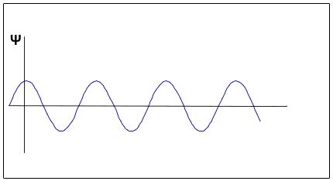
ψ
x

=> AND

both allowed simultaneously (subject to usual caveat about non-renormalizable states.)

But, it is NOT possible to have simultaneous eigenstates of
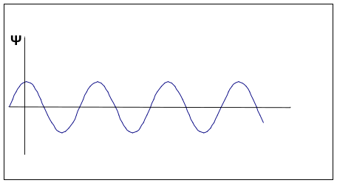
ψ
x
Can't
have
both!

This is very different from the classical situation:

x, p_{x} = m v_{x} ← can have well-defined,
precise values of x AND p_{x}

In QM, if we start with a state of definite p_{x} ( ψ = ) and we measure x, then

ψ collapses to a state of definite x (ψ =) and the momentum information is destroyed.

Theorem: If ,then there exist simultaneous eigenfunctions of

Proof: Given ψ such that , assume that Â ψ = a ψ, assume that ψ is a non-degenerate eigenfunction of Â. (We'll relax this condition later.) ψ = non-degenerate eigenfunciton of Â means that only ψ and multiples of ψ (=c ψ) are eigenfunctions. No other linearly independent eigenstates exist.

Now, operate with on both sides of Â ψ = a ψ:

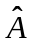

But assumed eigenstate of Â non-degenerate =>

is a multiple of for some b (Done).

So ψ is a state of definite A (value =a) and a state of definite B (value = b).

_________________________________________________

It can be shown that
(this would be a straightforward HW problem)
- if V = 0 = constant (free particle), then ∂ V / ∂ x = 0, and in this case [ , p_{x} ] = 0 => it IS possible to have states of definite energy and definite momentum.

Easy, we’ve seen this:

(But only true for free particle. If any V(x) ≠ const. present, then eigenstates of are not p eigenstates.)
Now that we have some familiarity with commutation relations, we can show how expectation values change with time:

Theorem: For any (linear hermitean) operator 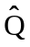 (that does not depend on time)
Proof:

Now,

On the other hand, we know
Note: (+) not (-), do you see why?

since H is hermitean

(As we claimed!)
________________________
So any observable Q whose operator commutes with the Hamiltonian H has
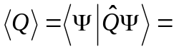constant in time for any time Ψ(x,t).
Q is conserved.
In classical mechanics, conservation of Q means Q = constant for isolated system.

In QM, conservation of Q means < Q > = constant.
Classically, measured conserved Q => get same Q every time. But in QM, if you measure a conserved Q, get one of the q_{n}'s 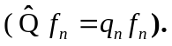 In QM, conservation of Q is only evident if you make many measurements on an ensemble of identical systems.
Examples:
● => < E > = constant.
We really already know this: 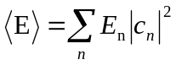 is time independent.

● => < x > changes with time in general.
In fact, we can work out the commutator on the left:

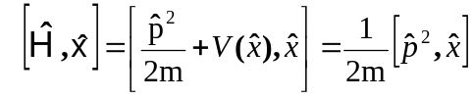
, which means

We’ve seen this many times before, but now it’s formally derived. It’s “Ehrenfest’s theorem”, and tells us that expectation values obey Classical Laws.

● You showed in a HW,
=> 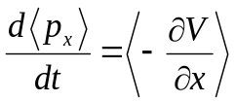

Ehrenfest again: It’s Newton’s 2nd law!!

Classically: 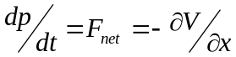

The Heisenberg Uncertainty Principle
Recall standard deviation 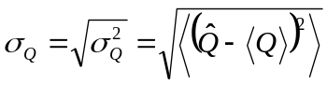
Classically, for any random variable x:
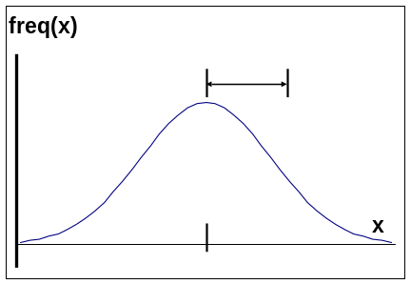

Theorem: (proof later) For any two (linear, hermitean) operators 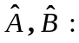

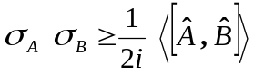 This is called a "Generalized Uncertainty Principle"

Example: 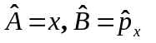

That’s the original Heisenberg Uncertainty Principle, derived now!

Often written (sloppily) Δx ∙ Δp ≈

=> if x known precisely (Δx ≈ 0 ), Δp very large
if p known precisely (Δp ≈ 0 ), Δx very large

Note: large Δp implies large p (since, if p known small => Δp small)

But if p large, then KE = p²/2m large. So, if Δx small (particle confined to small space) then 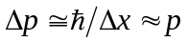 is large => energy is large:

We saw this in ground state of particle in infinite square well: 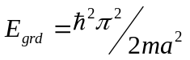
=> it always takes a big energy to confine particle to a small space.

Note: The Uncertainty Principle does not refer to uncertainty in the mind or even (just) the apparatus of the observer. The uncertainty is in Nature itself. If the particle has well-defined momentum, then is does not (can not) have a well-defined position.

Proof of Generalized Uncertainty Principle (same as in text):

(Â - <A>) hermitean defines f

Similarly,

This is called the Schwartz Inequality (proven in homework) Translating into more conventional “vector” notation, it’s equivalent to
Now < f | g > is some complex number z, and

=>

Now

(My notation here is that
I know that <A> is real, so it comes out of the ket

Thus,

Putting it all together, then,
Which is the “generalized uncertainty principle”, done.

*

In addition to the position-momentum U.P. :

there is the time-energy U.P. : . This looks similar, but is quite different.

In QM, time t is a parameter, not an observable. You don't measure "the time of a particle". There is no observable corresponding to time in (non-relativistic) QM.

Δt ≠ uncertainty in time measurement (there is no "expectation value of time")

Δt = time interval for system "to change significantly” (made precise below)

Recall

Define Δ E = σ_{H} = ( 1 sigma ) uncertainty in energy.

Define , and we have our Energy-time U.P.
Δt is time required for < Q > to change by 1 standard deviation σ.

Examples:
● If Ψ is energy eigenstate, E known exactly => ΔE = 0 => Δt = ∞.

It takes forever for a stationary state to change.

● If Ψ is superposition of E-eigenstates, E₁ & E₂ say, then ΔE ≈ | E₂ - E₁| and
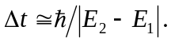 This is consistent with what we’ve seen before on homeworks:
.

